**NASA EVA**

**Gamification**

**M E D I A W I K I I N S T A L L (C E N T O S 7)**

**PHASE II**



**Prepared By**

Laura Addiego

Samia Alam

Kelli Corey

Charles Milk

Adeola Odusola

Hung Pham

Table of Contents

Introduction 3

Document Overview 3

Obtaining the CentOS 7 image 3

Virtual Box 4

Software Installation 4

Extension Pack Install (Optional) 8

**Creating a Virtual machine** 11

Machine setting adjustments 15

Installing CentOS 7 18

Starting the Virtual machine 19

Preparing for Software Installation 41

Install Apache web server 44

Installing MariaDB 47

Installing PHP 50

Install MediaWiki 52

NASA EVA Gamification Extension Installation Instructions 63

Additional Tips 66

Earning Points 67

By Creating a Page 67

By Editing a Page 67

Checking Your Points and Badges Earned 68

Appendix A - Enabling Virtualization 69

|  |  |  |  |
| --- | --- | --- | --- |
| **Version Number** | **Description of Change** | **Author** | **Date** |
| 1.0 | Initial Creation of Document | Kevin Fortier | 04/07/2018 |
| 1.1 | Formatting corrections | Michael Salgo | 04/10/2018 |
| 1.2 | Added additional networking options and steps to install the NASA_EVA_Gamification extension | Kevin Fortier | 04/14/2018 |
| 1.3 | Added additional steps for NAT install | Michael Salgo | 04/17/2018 |
| 2.0 | Review Installation and updated with DVD ISO instructions | Laura Addiego Prospero | 08/06/2018 |

# Introduction

## Document Overview

This document will detail the steps needed to get a MediaWiki environment up and running on a CentOS 7 operating system. This document will also provide guidance on installing Oracle’s VirtualBox software on a Windows host system, so the CentOS 7 install can run as virtual machine. It is assumed the reader is minimally familiar with networking basics, Windows and Linux administration, and has the required permissions on their Windows host for software installation.

All screen captures are taken on a Windows 10 host machine, installing VirtualBox 5.2.8, for a CentOS 7 Build 1708 image. Future versions of the software above, may differ slightly in their presentation.

# Obtaining the CentOS 7 image

The following instructions use DVD ISO which can be downloaded from <https://www.centos.org/download/>. It is advised to verify the download via checksum before using the image.

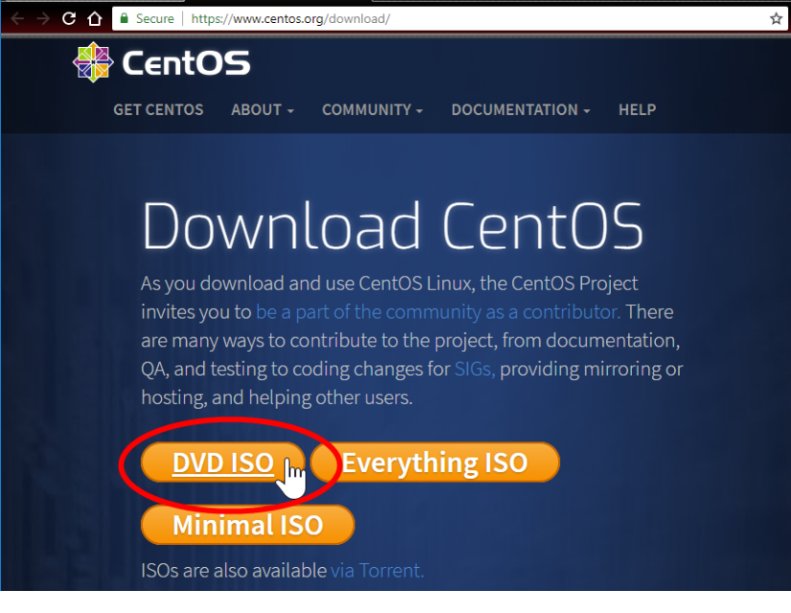

# Virtual Box

## Software Installation

This section can be skipped, if there is a host system which can directly take the CentOS 7 install. Otherwise, the VirtualBox software can be used to create a virtualized system which can run inside of a Windows host.

These steps are provided as guidance only. If problems arise during the install or alternative options are picked during install, please visit <https://www.virtualbox.org/> for additional reference.

1. Obtain Oracle VirtualBox software from <https://www.virtualbox.org/wiki/Downloads>. The guide will use the Windows hosts installation package.

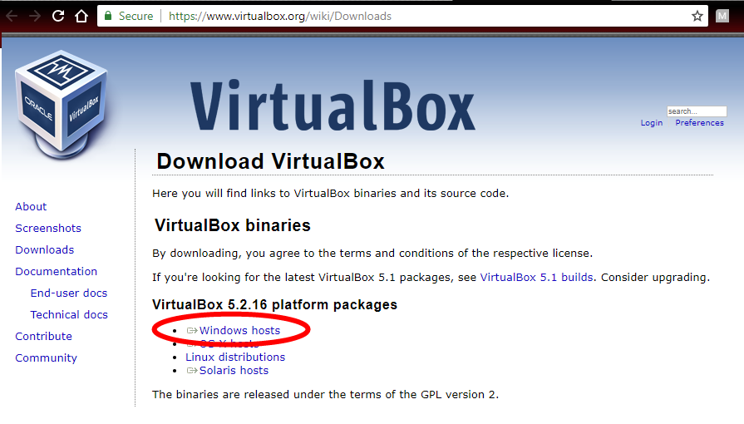

1. Run the downloaded installation package. If the user on the Windows host has non-elevated privileges, the installation package should be run as an Administrator.  
   Click the Next > button on the initial Setup Wizard screen.

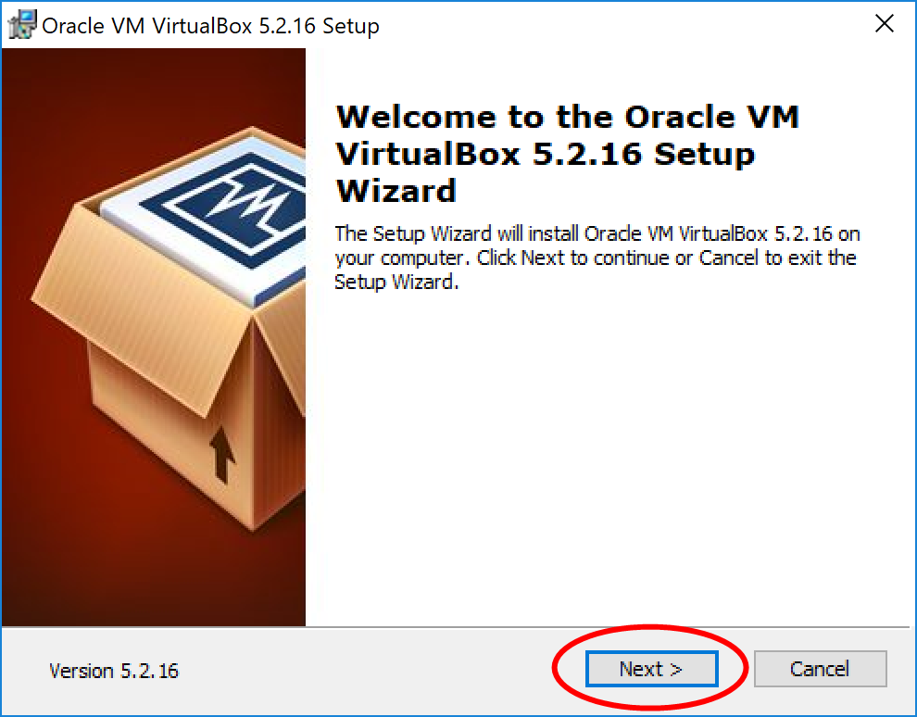

1. Custom Setup. Leave the features to be installed as the default.
   1. Click the Browse button to select a different install location if desired.
   2. Click the Next > button when satisfied with the selections.

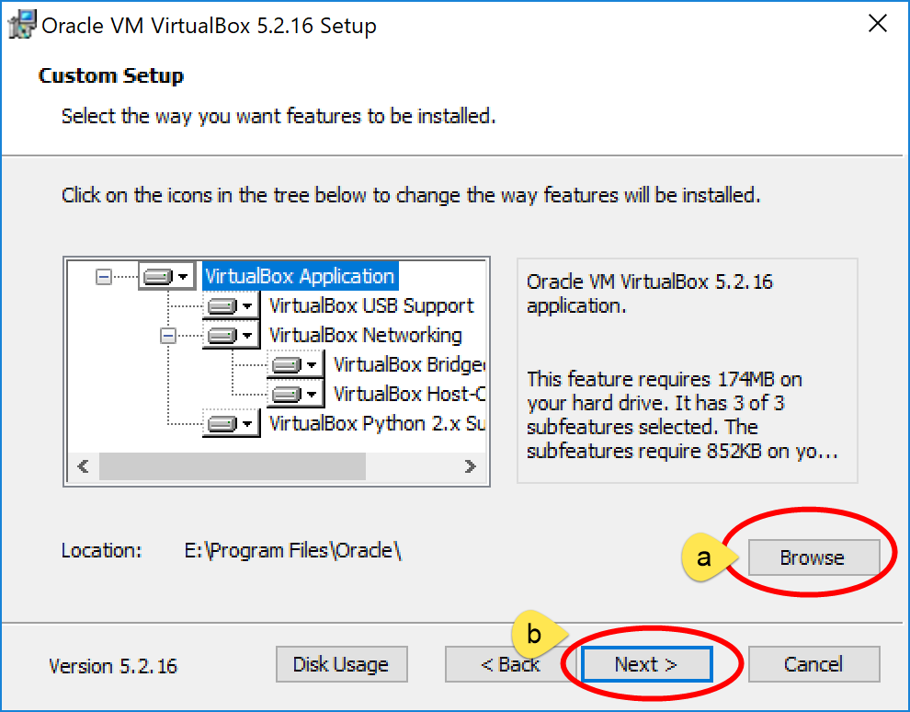

1. Select which options to additionally install, based on personal preference. It is advised to keep the “Register file associations” and “Create start menu entries” checked. Click the Next > button after making any adjustments.

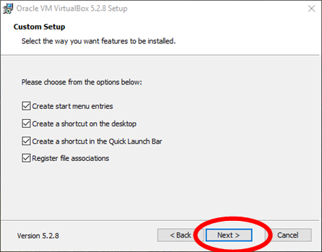

1. The software will add features related to any networking interfaces on the host machine. As a result, network connectivity may be impacted during the install. Click Yes to proceed.  
   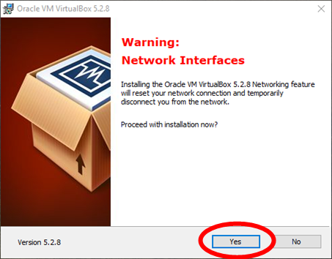
2. Click the Install button to start the install.  
   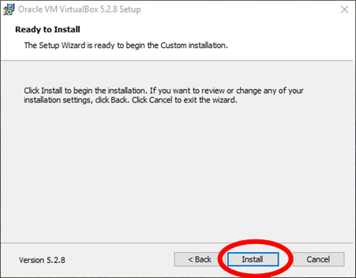
3. Windows Security messages may appear after starting the install. Click Yes on any messages of these type to allow the installation to continue.  
   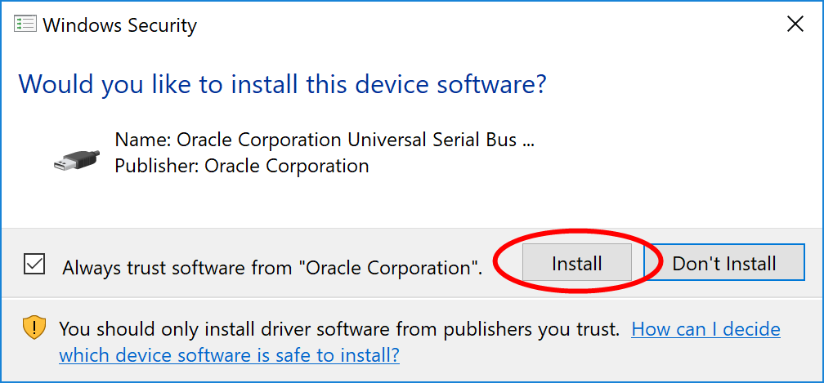
4. After some time, the installation will finish. Click the Finish button, which will launch the software.  
   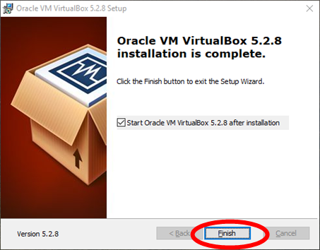

## Extension Pack Install (Optional)

While not needed for the VirtualBox software to work, it is highly advised to install the Extension Pack. It contains support for USB 2.0 and USB 3.0 devices, disk encryption, and other features which provide a better user experience, in terms of use and administration. The steps below will guide through the process of installing the Extension Pack.

1. Close the VirtualBox software, if started from the install process.
2. Go to the VirtualBox website and navigate to the Downloads page: <https://www.virtualbox.org/wiki/Downloads>.
3. Click on the “All supported platforms” link under the Extension Pack section to begin the software download. The file should end with “.vbox-extpack”.

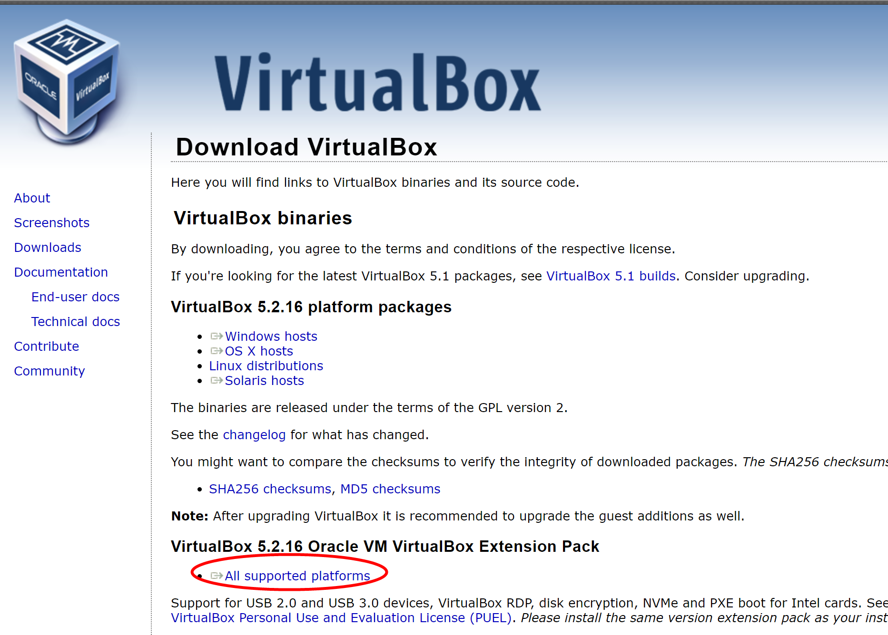

1. Click the Install button to proceed with the installation.  
   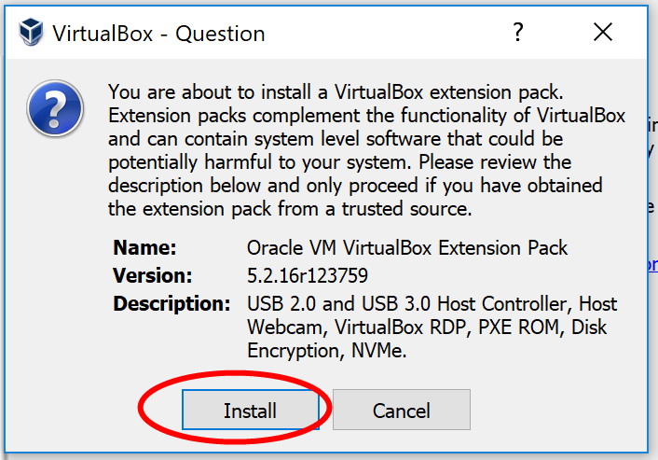
2. Scroll to the bottom of the text box and click the I Agree button on the License window.  
   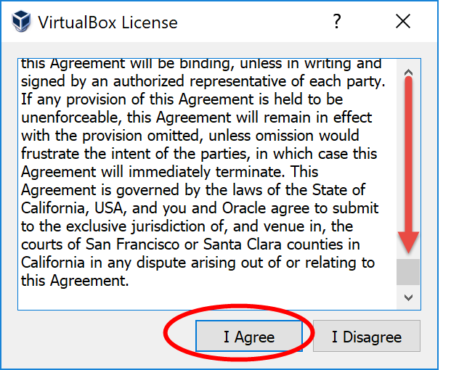
3. If any Windows UAC prompts appear, click Yes to install the software.
4. Click OK, after the extension pack has finished installing.  
   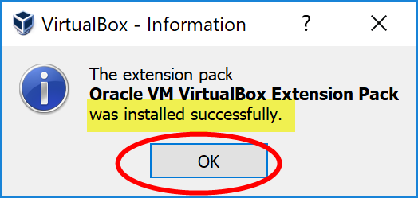
5. After the extension installation completes, double-check that it has been successfully installed.

Navigate to File > Preferences > Extensions; you should see the extension with a green check-mark next to it. Cllick OK.

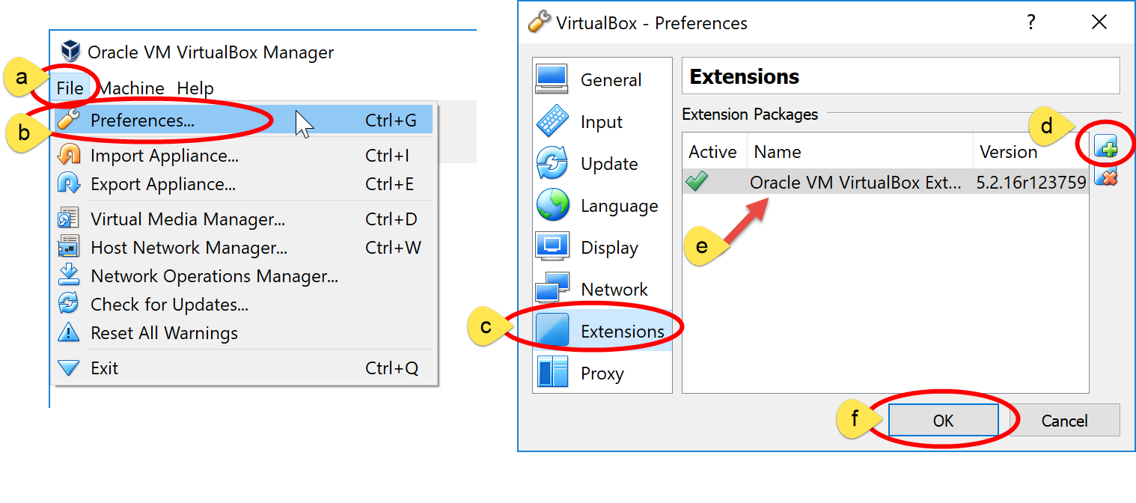

# **Creating a Virtual machine**

The following steps will detail how to create the CentOS 7 Virtual Machine (VM). The screen captures included below are from VirtualBox software which has the Extension Pack installed. If the Extension Pack was not installed, some options may not be available.

1. Start the VirtualBox software if not already running. Insure that the software is in Machine Tools view.
2. Click on the “New” button.

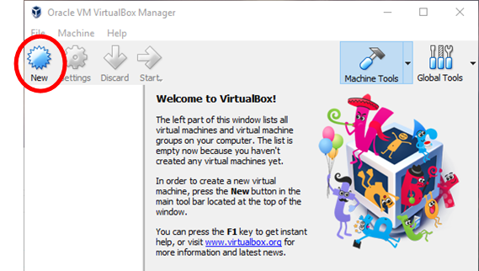

1. Name and operating system
   1. Give the virtual machine a name
   2. Select “Linux” for Type
   3. Select “Red Hat (64-bit)”. Since there is no CentOS as a choice, Red Hat is the most similar to CentOS and it will give you the same environment, so we are going to use this version.
   4. 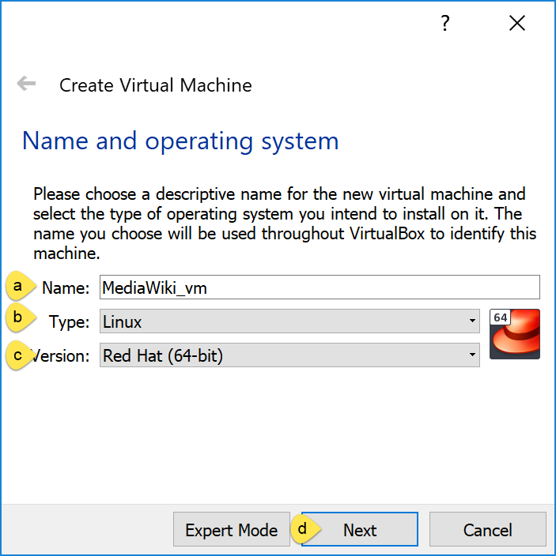Click the Next button when done.

**NOTE:** If when selecting the Version, you only see “32-bit” options, and you are sure your host machine is 64-bit, this means your virtualization technology in the BIOS is not enabled. See “Appendix A – Enabling Virtualization” at the end of this document.

1. Memory size
   1. Adjust the memory size to give to the VM. This setting will be highly dependent on the total memory of the host system. A value of 2018 MB is recommended if the host machine has at least 8GB of RAM or higher.
   2. Click Next after adjusting the value.  
      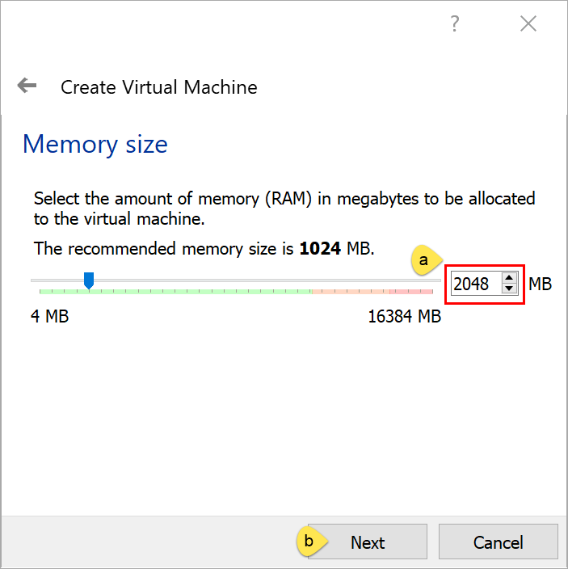
2. Hard disk
   1. The recommended size of 8.00GB is sufficient. The value can be increased if desired. Make sure the “Create a virtual hard disk now” option is selected
   2. Click the Create button.  
      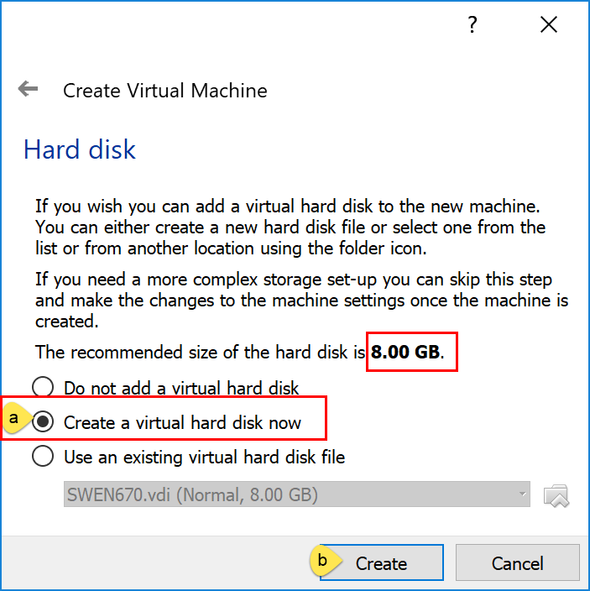
3. Hard disk file type
   1. The default VDI disk file type can be selected. Other options can be used if more familiar with different virtual machine software.
   2. Click Next to continue.  
      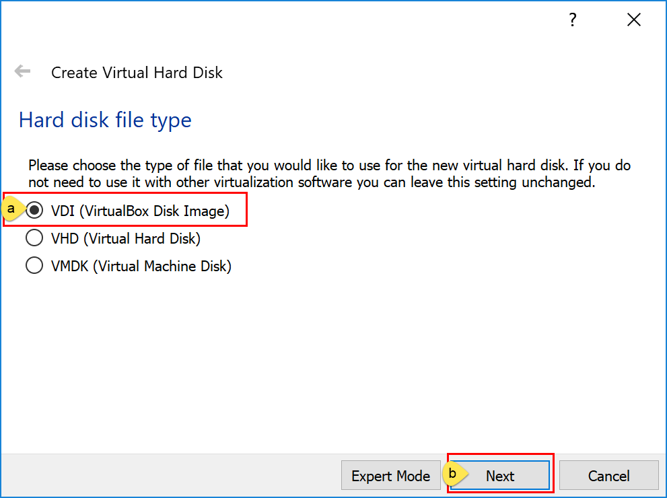
4. Storage on physical hard disk.
   1. It is recommended to use the “Dynamically allocated” option. This will keep the footprint of the VM as small as possible.
   2. Click Next to continue.  
      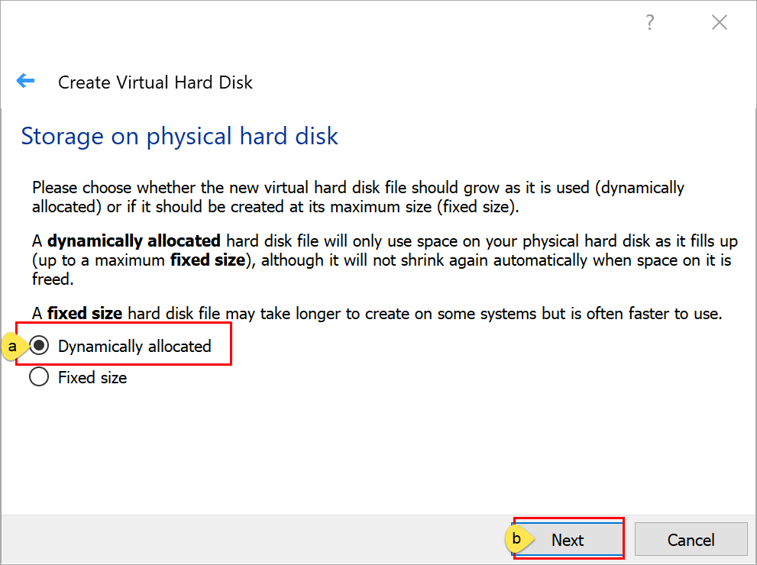
5. File location and size.
   1. Select the folder icon if you would like to give the virtual hard disk a different location.
   2. The disk size and location can be adjusted here, if the defaults are not desired.
   3. Click the “Create” button to continue.  
      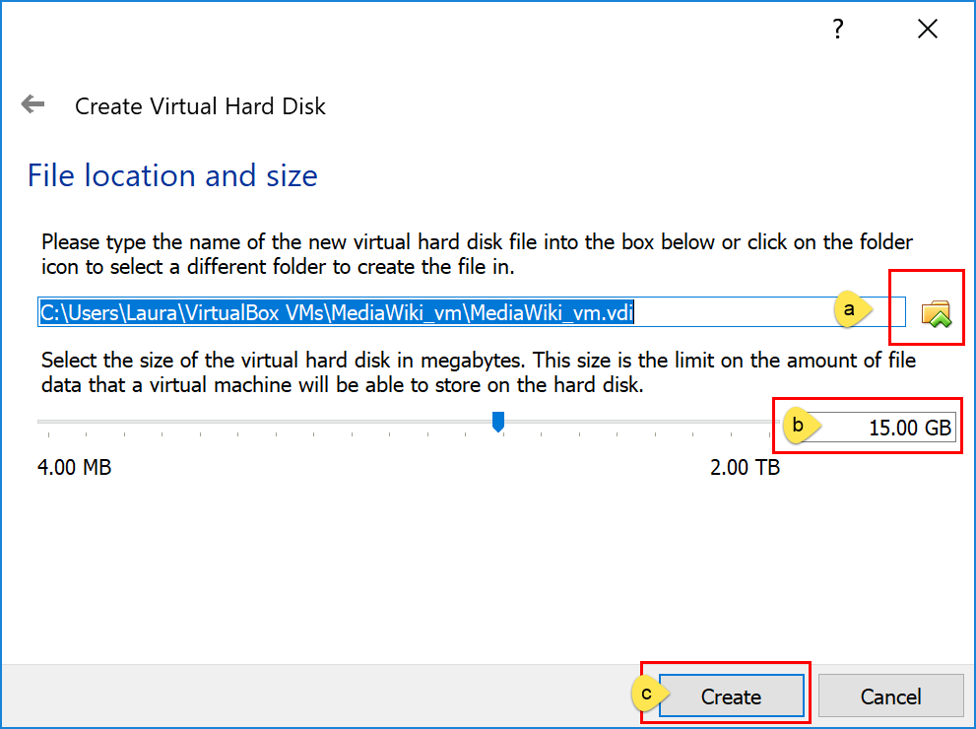
6. The VM should be created and Powered Off in the Machine Tools view.  
   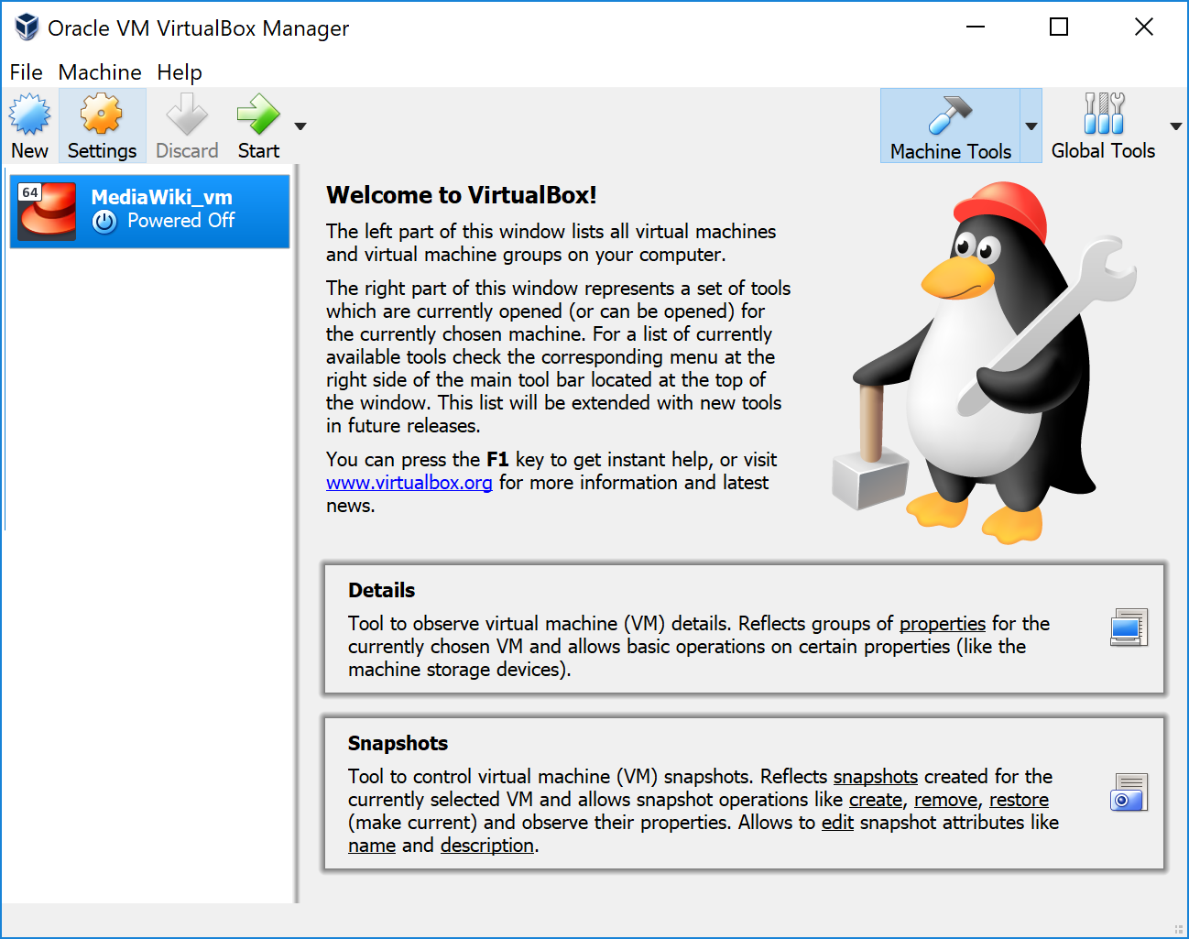

## Machine setting adjustments

After the creation of the VM, and before we power up the machine, a few settings needs to be changed for better performance and usability.

1. Accessing the settings.
   1. Highlight the VM created in the previous steps
   2. Click the Settings button.  
      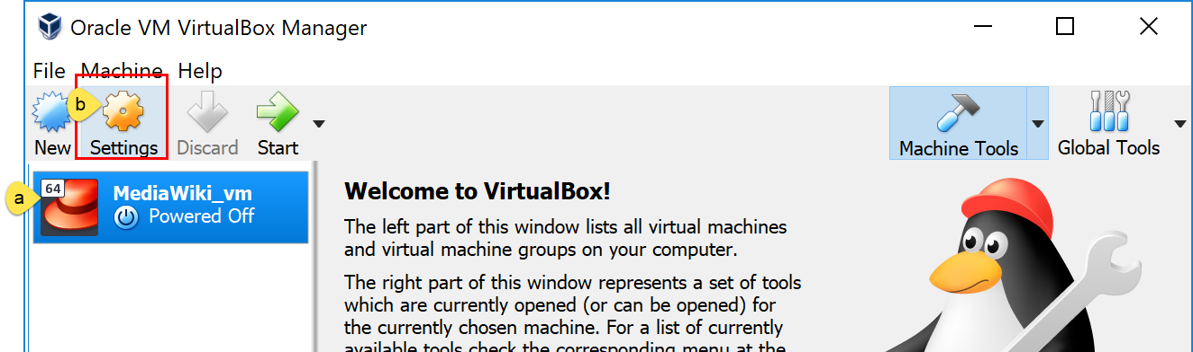
2. System > Motherboard tab
   1. Under the System/Motherboard menu,
   2. The Floppy option can be unchecked.
   3. This is also where the memory settings to the VM can be adjusted after creation.  
      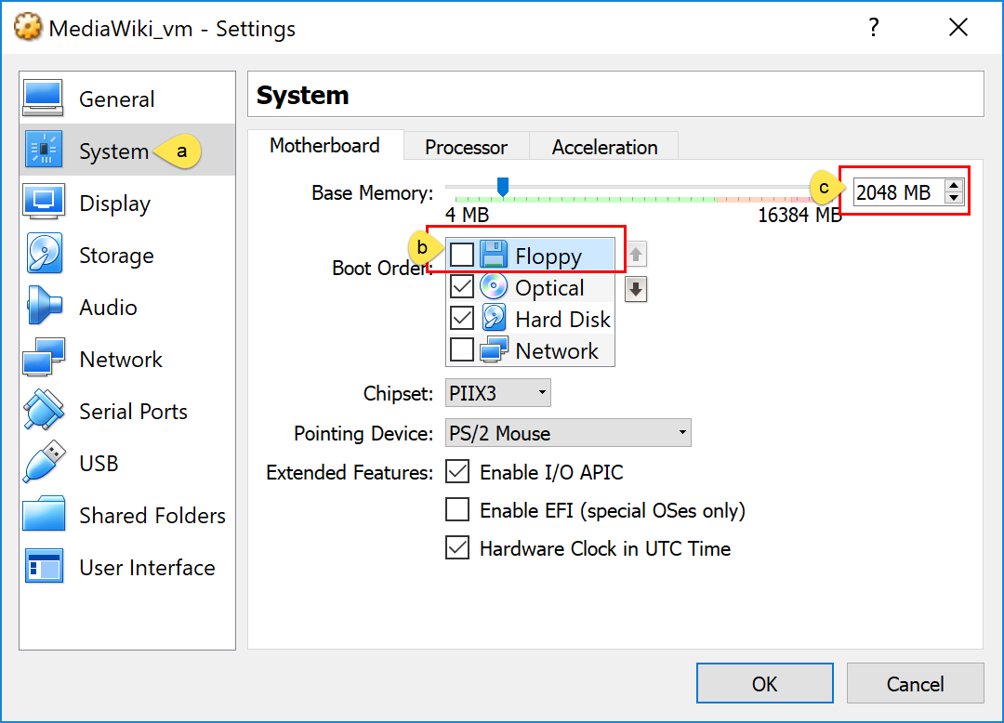
3. System > Processor tab,
   1. Click on the “Processor” tab.
   2. The Execution Cap should be adjusted to 90%. This will prevent the VM from completely consuming CPU resources on the host machine, if it is CPU bound for an extended period. If the host machine’s BIOS supports it, the Enable PAE/NX should remained checked.  
      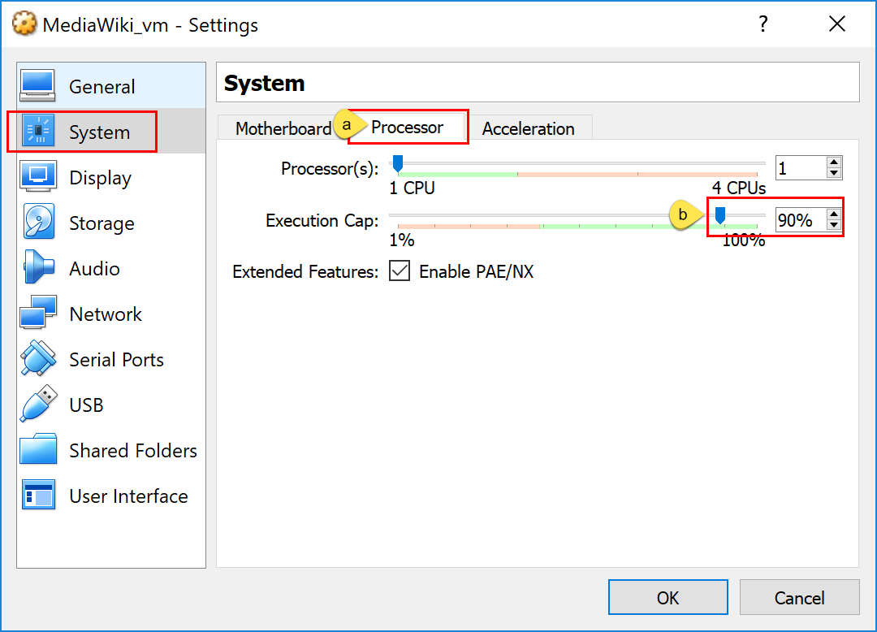
4. Network / Adapter 1 tab,
   1. Click on “Network”
   2. Make sure you are on the “Adapter 1” tab.
   3. Ensure the “Enable Network Adapter” is checked.
   4. The selection of “Attached to” is best left to the individual configuration of the host machine and how it connects to a network. Greater detail and images can be found at <https://blogs.oracle.com/scoter/networking-in-virtualbox-v2>. A quick summary of options to consider, which allow for Internet connectivity, are:

**NAT**: The host machine will assign the VM an IP address of 10.0.2.15. All network traffic will depend on the host for communication, but this allows the host machine to move between networks (wired vs. wireless) without interruption to the VM.   
 If using NAT:  
 1. click on the “Adapter 2” tab  
 2. Check “Enable Network Adapter” checkbox.  
 3. For “Attached to:” set it to “Host-only Adapter.”   
This will be used to SSH/interact with the VM from the host machine.  
**Bridged Adapter**: This will place the VM directory on the network. It will be dependent on the host’s network interface for a connection but will otherwise present on the network like an independent machine. This option is ideal for wired-only hosts.

In this guide we will be using NAT .

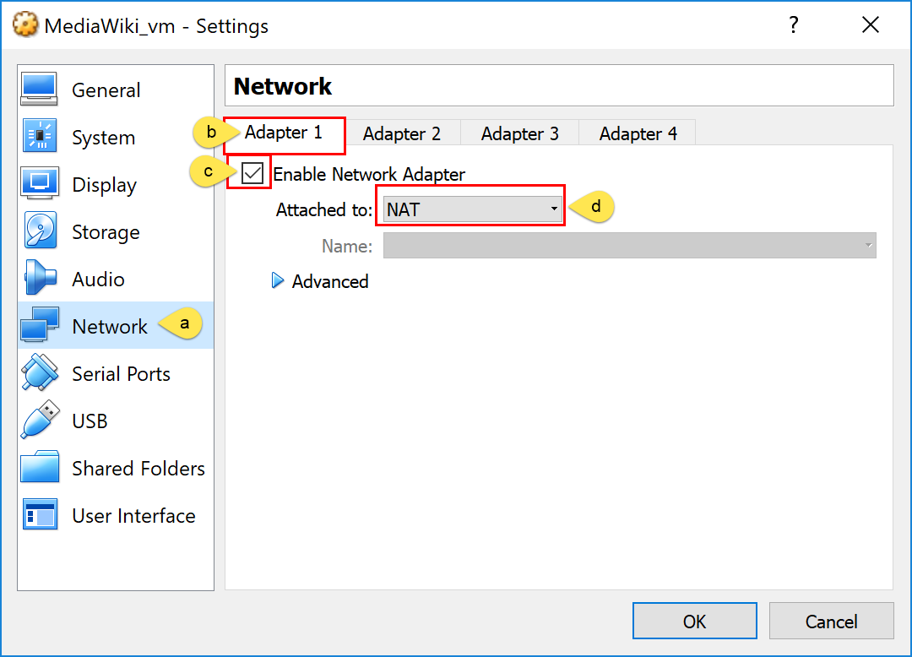

1. Network / Adapter 2 tab,
   1. Click on “Network”
   2. Make sure you are on the “Adapter 2” tab.
   3. Ensure the “Enable Network Adapter” is checked.
   4. The selection of “Attached to” select “Host-only Adapter”

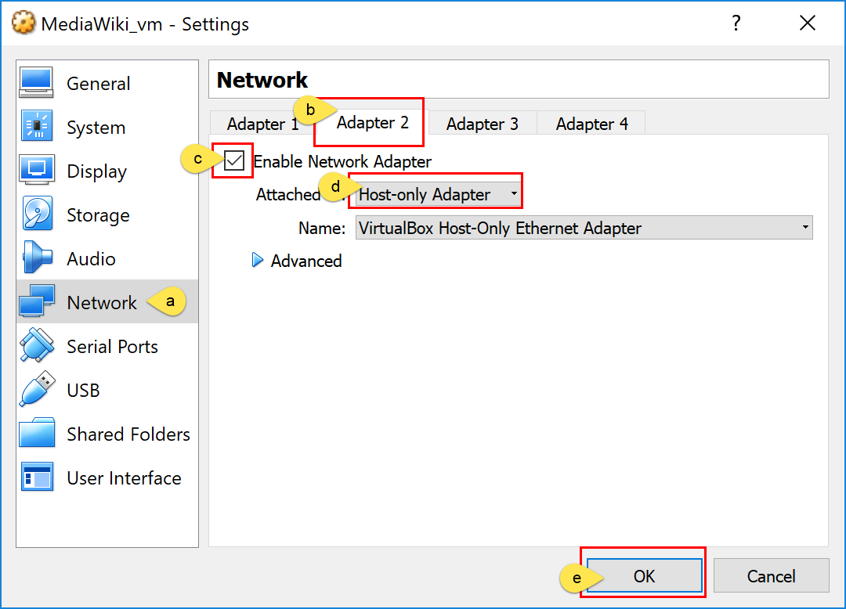

Other options can be selected, based on the needs of the host admin. The above settings are just recommendations for a VM which can support the CentOS 7 install for the SWEN670 course. Click the OK button when finished.

## Installing CentOS 7

The ISO image downloaded previously from <https://www.centos.org/download/> should be mounted to a removable medium. The steps below are designed to install to the previously created VirtualBox VM.

1. Highlight the VM and click the Settings button.
2. Navigate to the Storage menu and
3. Select the empty CD -ROM
4. click on the CD ROM icon to highlight the IDE Secondary Master setting.
5. select the “Choose Virtual Optical Disk File”.
6. Find and select the downloaded ISO file and click Open to return to the previous window.
7. Click OK to return to the VirtualBox Manager window.  
     
   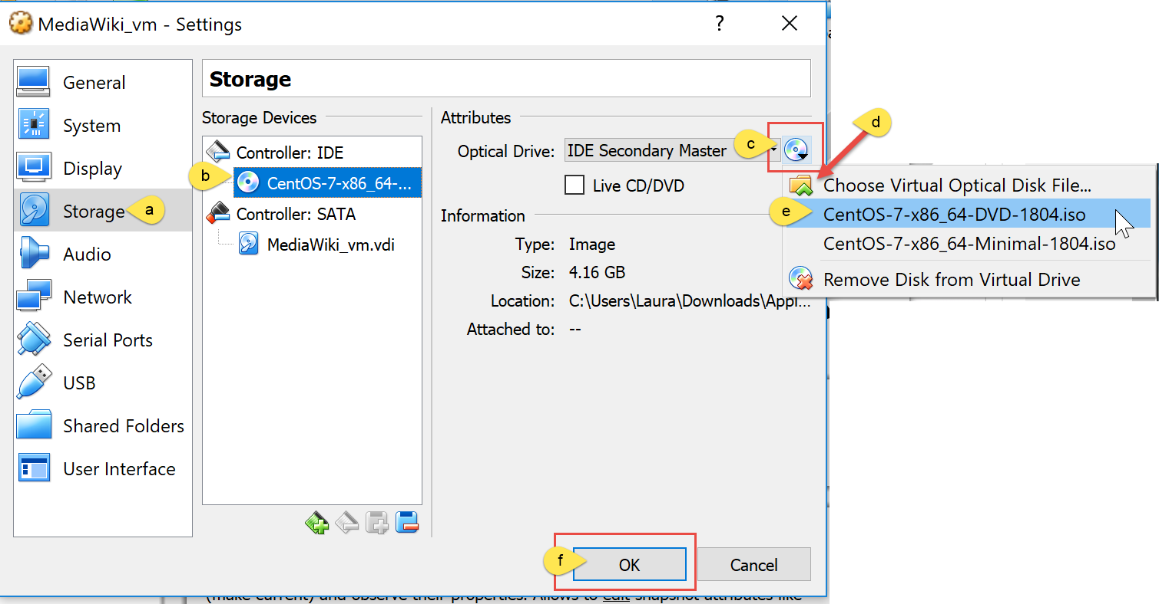

## Starting the Virtual machine

1. On the VirtualBox Manager, select the virtual machine and click on “Start”  
   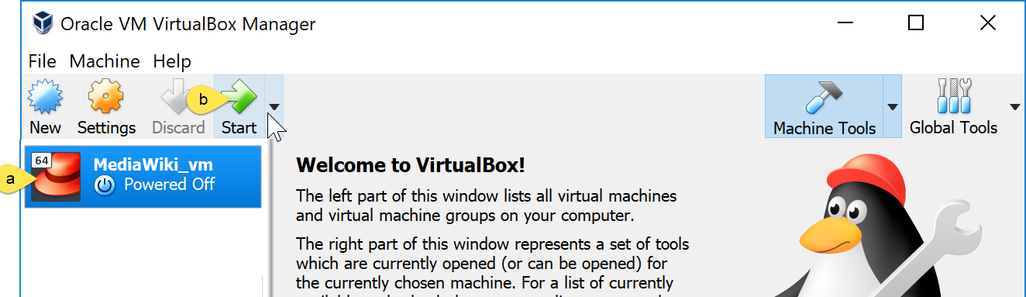
2. A new window will open.  
   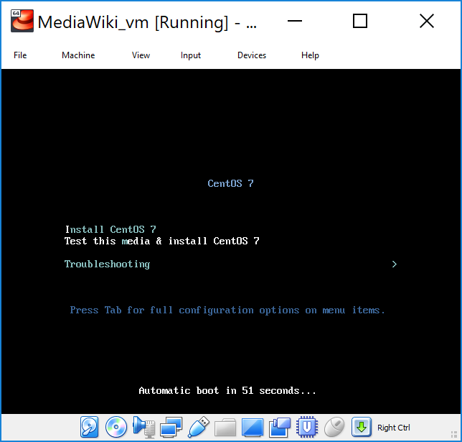
3. Press the Enter key to select the “Test this media & install CentOS 7” option.
4. The process will verify the integrity of the ISO image and launch the CentOS 7 installer.

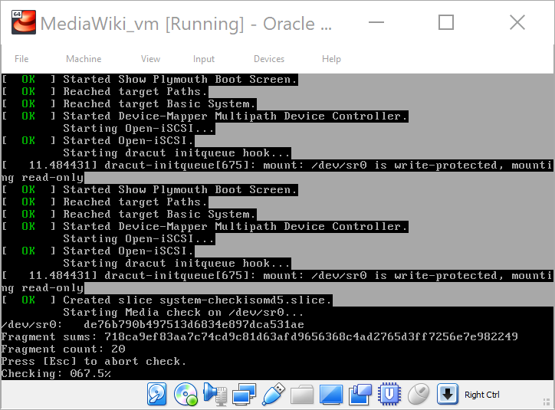

1. Select English from the left-hand menu and English (United States) from the right-hand menu (or your preferred language). Click the Continue button to move forward.  
   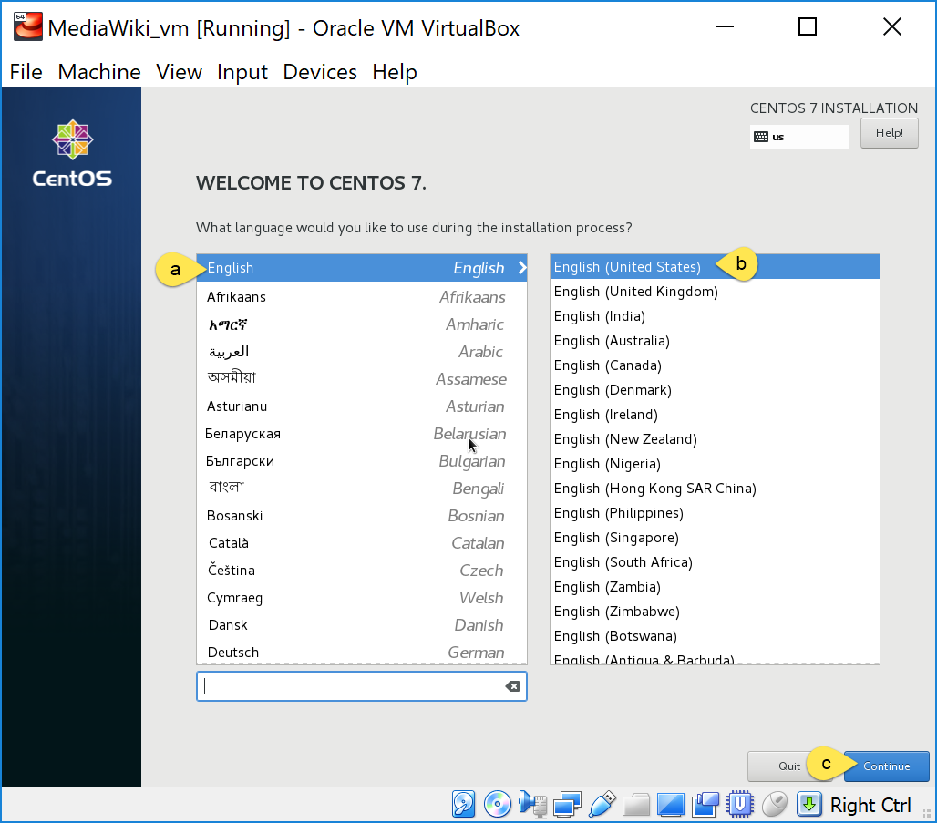
2. A pop-up message will tell you about the “host key”, which by pressing you will be able to navigate out of the virtual machine into your host computer. In this case it is pointing to the “Ctrl” key that it is to the right of the space bar on your keyboard.
   1. Check “Do not show this message again.
   2. Click on “Capture”

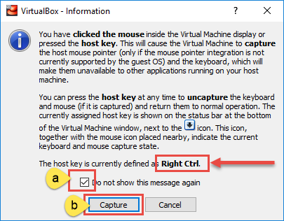

You will still be at the ‘language selection’ window. Click on “Continue” again.   
You will be directed to the “Installation Summary” window.

1. Click on “SOFTWARE SELECTION”

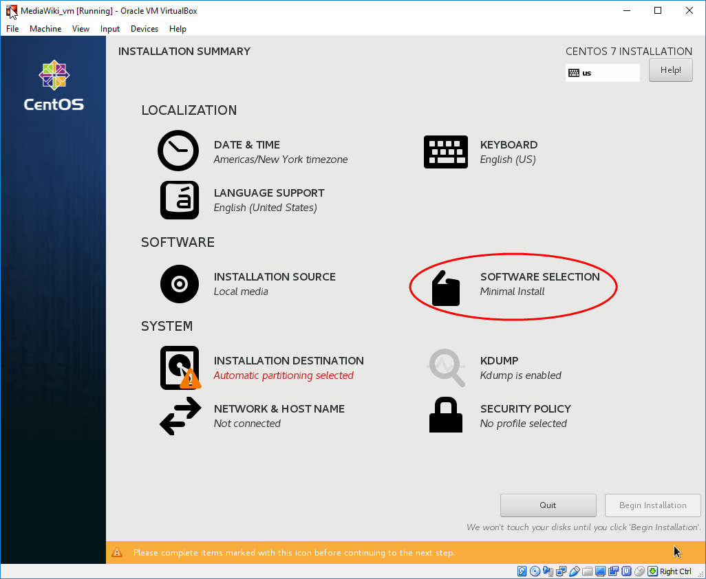

* 1. On the “Software Selection” window, select “Server with GUI”. On the right side, you will see a list of Add-Ons that could be installed when the OS is installed. Personal preference is to manually install it at a later time.
  2. Click on “Done” (upper left corner).

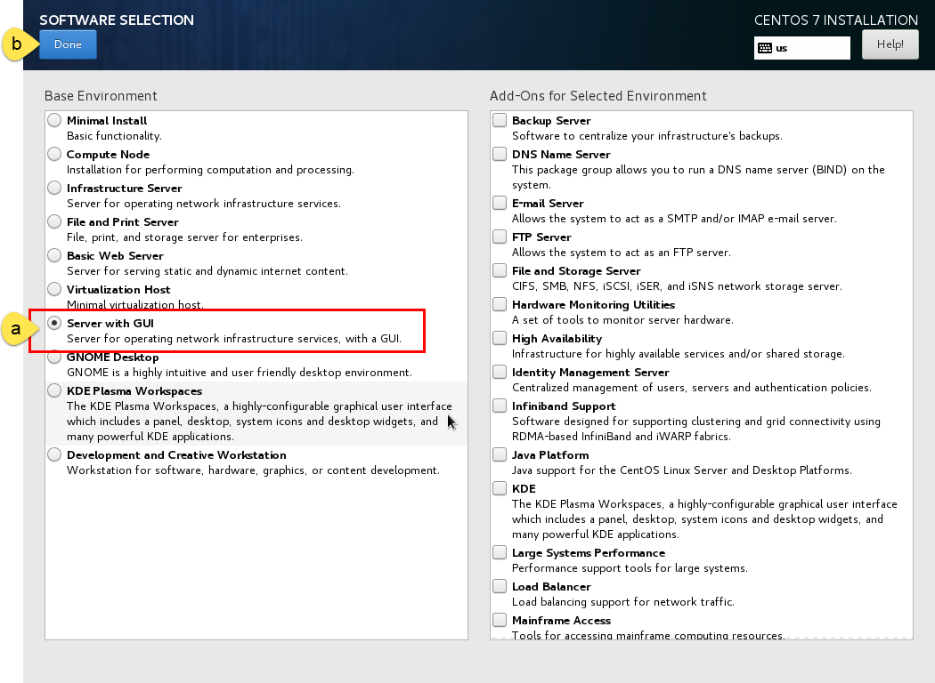

1. Click the INSTALLATION DESTINATION item.

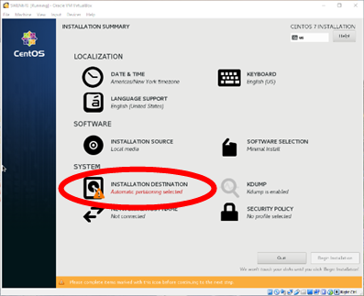

* 1. Click the ATA VBOX HARDDISK option twice, so a black checkmark appears on the ATA image;
  2. Click the Done button at the top of the screen.  
     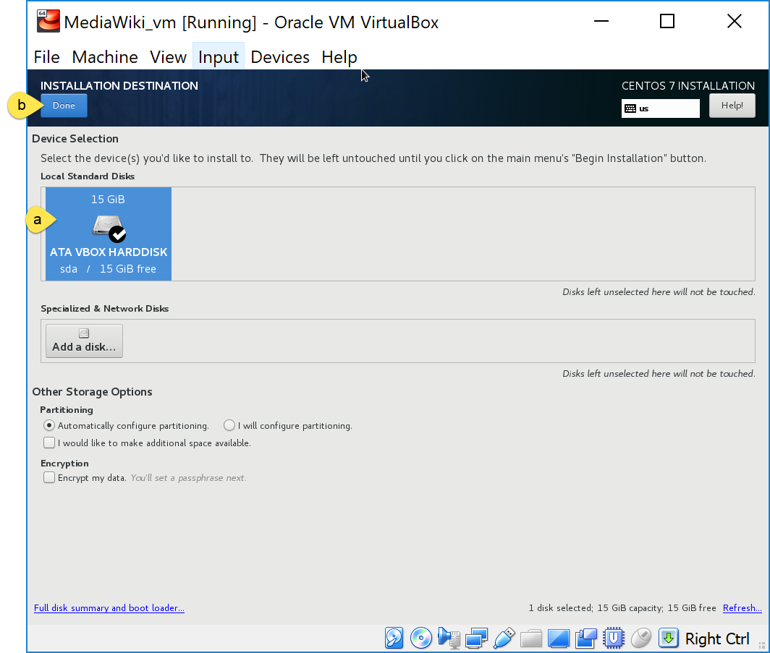

1. Click on “Network & Hostname”.

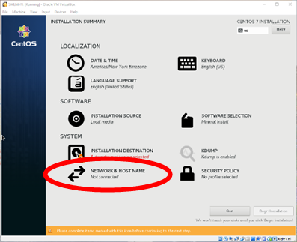

Turn ON the Ethernet connection at the top right of the screen. Network details will fill in as the system obtains an IP address through the network’s DHCP service. If a static address is desired, it can be configured here, or through a static lease type within the network’s router. Both are out of scope of this document.

* 1. Click on one Ethernet connection.
  2. Turn it on
  3. Take a note of the IP address that it is assigning you.

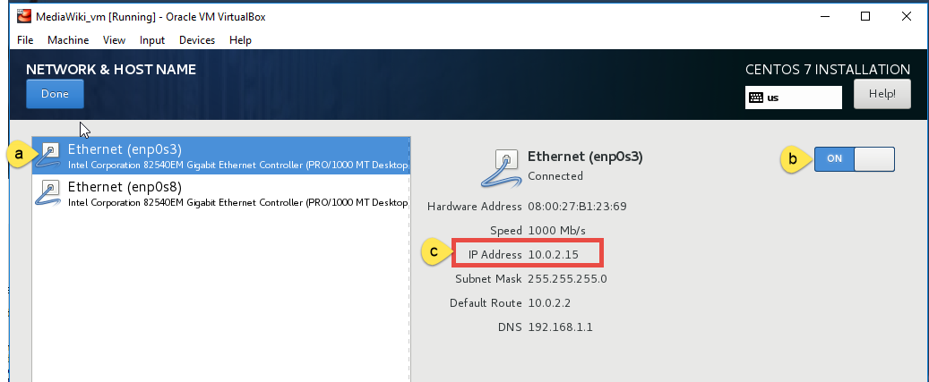

* 1. Click on the other ethernet connection.
  2. Turn it on
  3. Write down the assigned IP address; you will need it in the future.
  4. Click the blue “Done” button at the top-right corner of the screen when done with the network configuration.

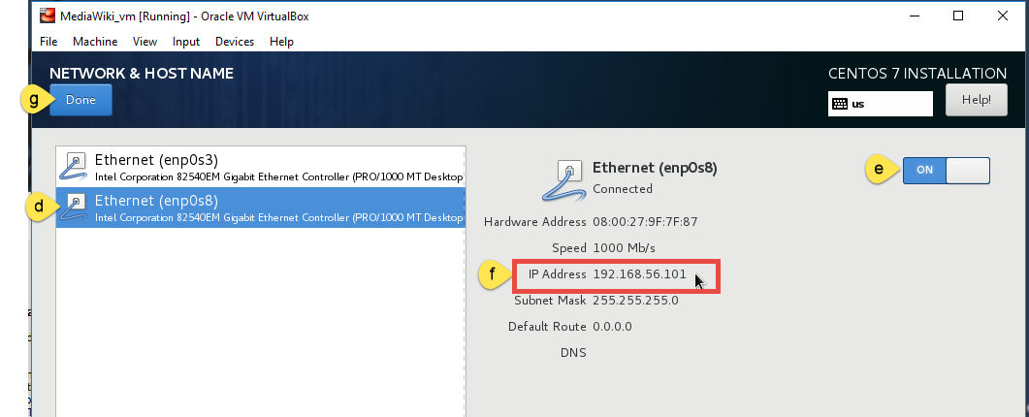

1. If there are any additional items with a yellow warning icon, they will need to be resolved before continuing.

Otherwise, click the Begin Installation button.  
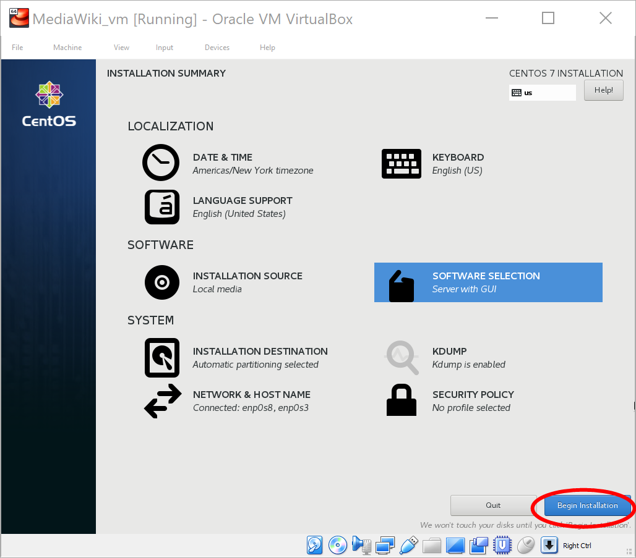

1. The installation will begin and can be tracked by the progress bar at the bottom of the screen. While the install is running,
   1. Define the ROOT PASSWORD item. (detailed steps will follow)
   2. Create a non-administrator user. (detailed steps will follow)

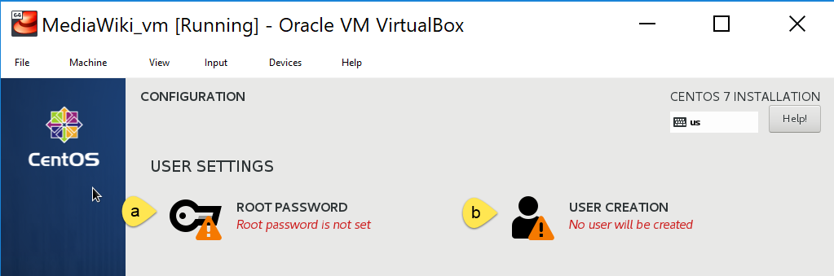

1. Define the ROOT PASSWORD
2. Set the root password.   
   Do not lose this password. You may want to write it down as you will be using it on multiple occasions.
3. Re-type the password in the “Confirm” input box.
4. Click the Done button when complete.

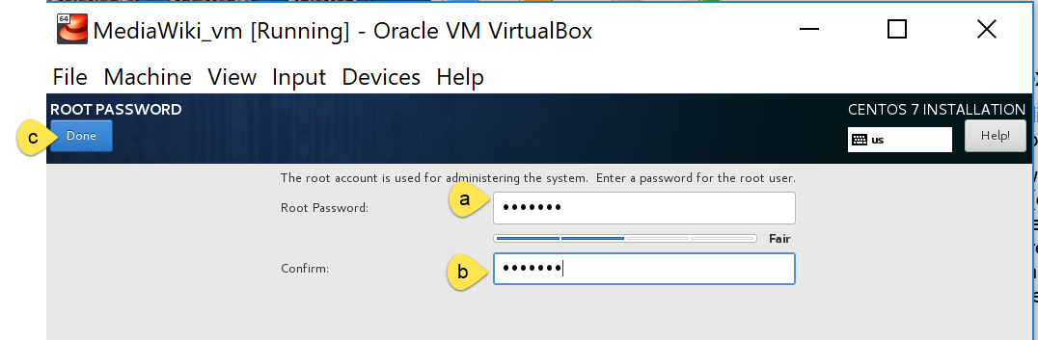

1. USER CREATION.   
   Create a **non-administrator** user for the system.
   1. Give it a name and full name.
   2. Define a password
   3. Re-type password
   4. Click on the “Done” button when complete.

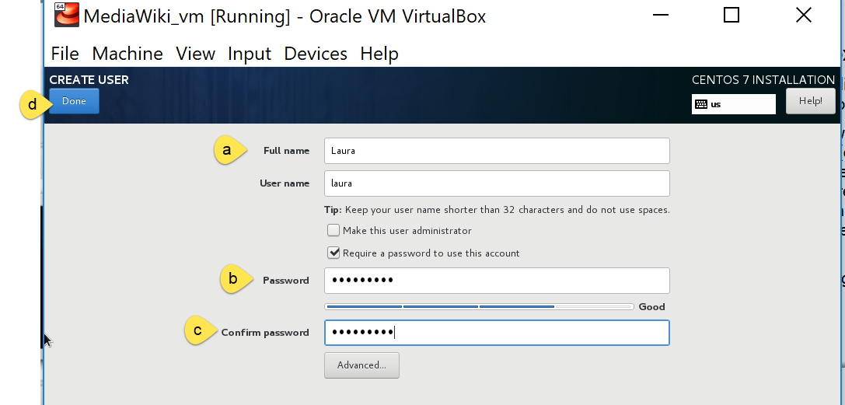

1. Finish Configuration

Depending on how quickly the root password and user creation is done, the installation process may not be finished; additional wait time may be required. When the installation process is complete, a blue “Finish Configuration” button will appear.

* 1. Click that button to complete the install.

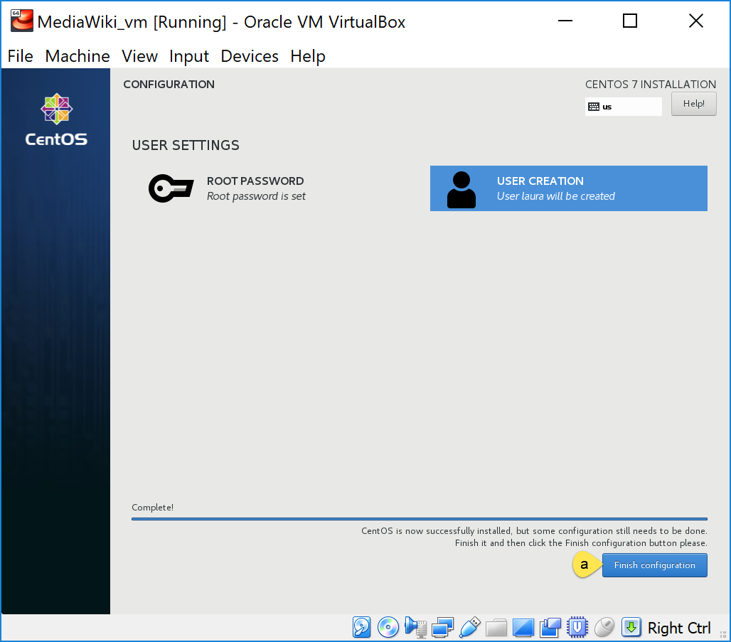

1. Reboot.

Additional configuration items will run. A blue “Reboot” button will appear when the remaining configuration items are complete.

* 1. Click “Reboot” button.

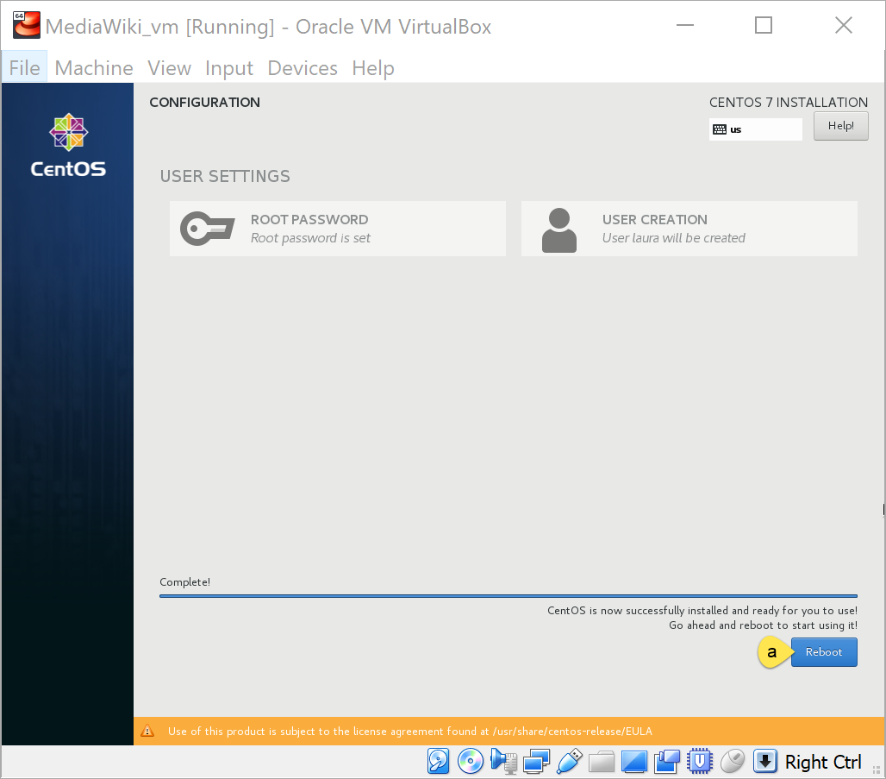

1. Finish Configuration. – While this is taking place the virtual machine may turn black and you might see a series of process running.

The system will bring the “INITIAL SETUP” screen, where you will have to:

1. Accept the licensing
2. Enable network connectivity
3. Finish configuration

Screenshots of the process will follow.

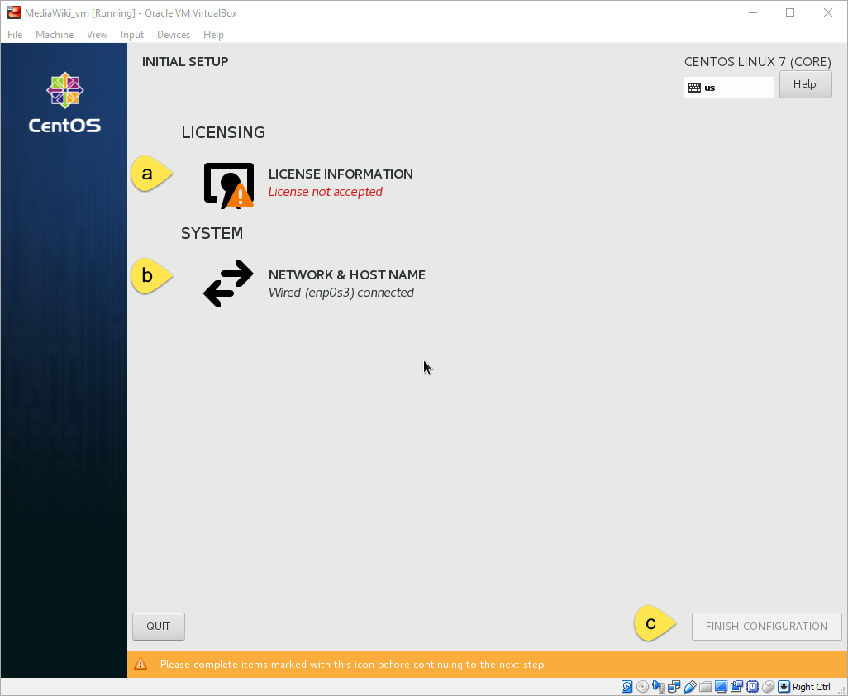

1. Accept Licensing
   1. Click on “I accept the license agreement.”
   2. Click on “Done”.

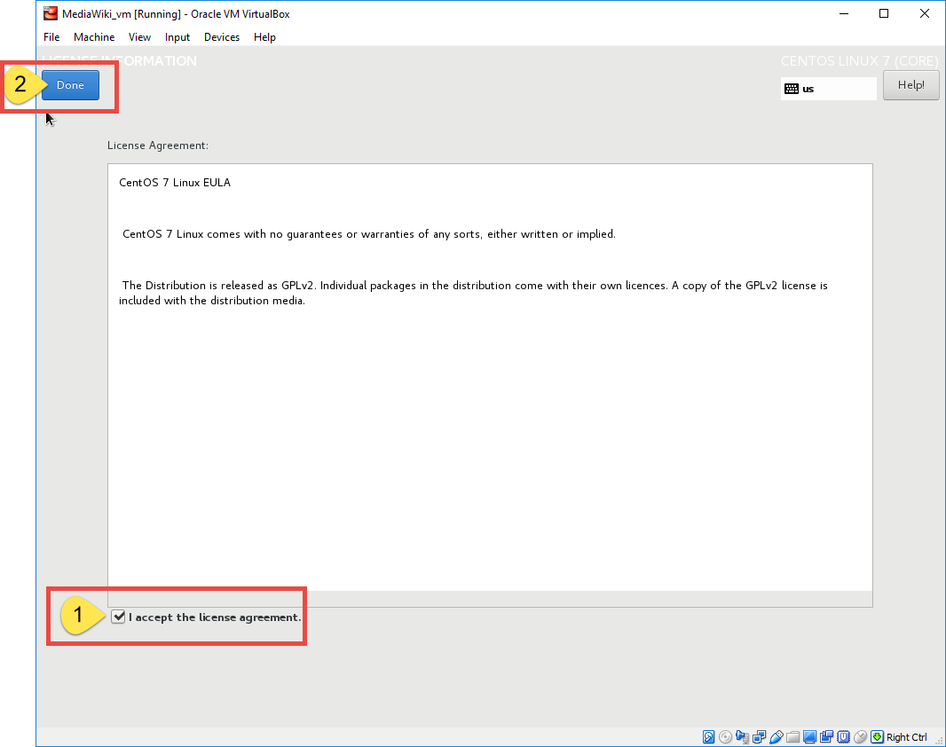

1. Network & Hostname: Enable network configuration
   1. Click on one Ethernet
   2. Make sure it is on, if it is not, turn it on.
   3. Confirm that the given IP address is the same as the one you wrote down.

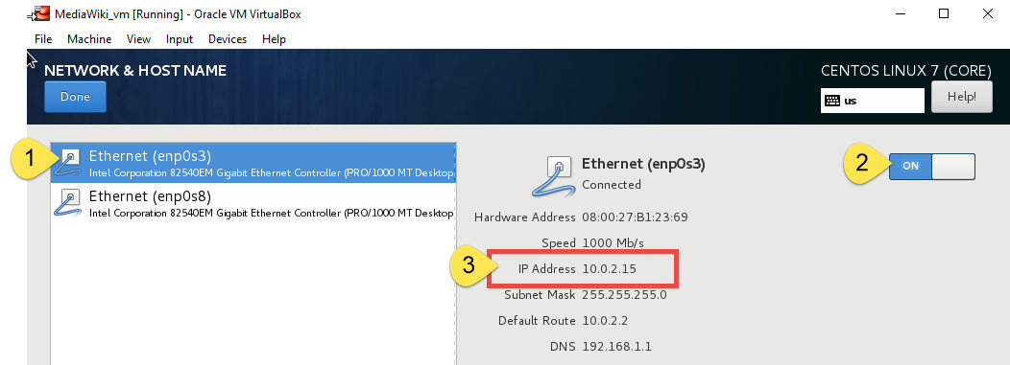

* 1. Click on the other Ethernet connection.
  2. Make sure it is turned on, if not, turn it on.
  3. Confirm that the given IP address is the same as the one you wrote down.
  4. Click on “Done”

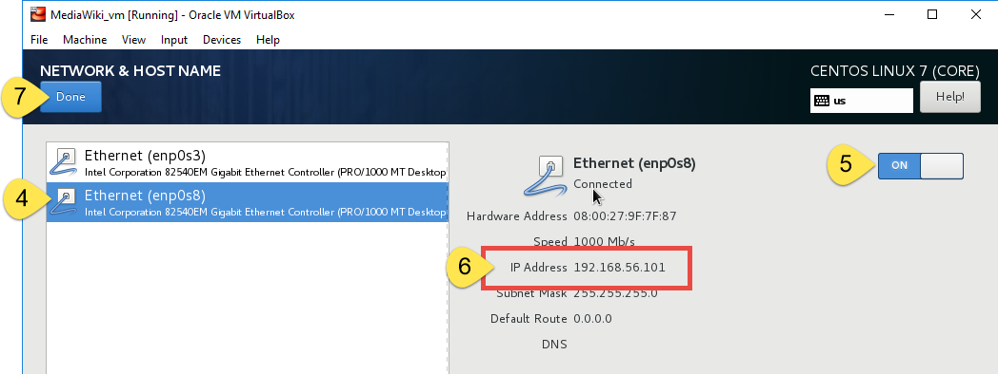

1. Finish configuration

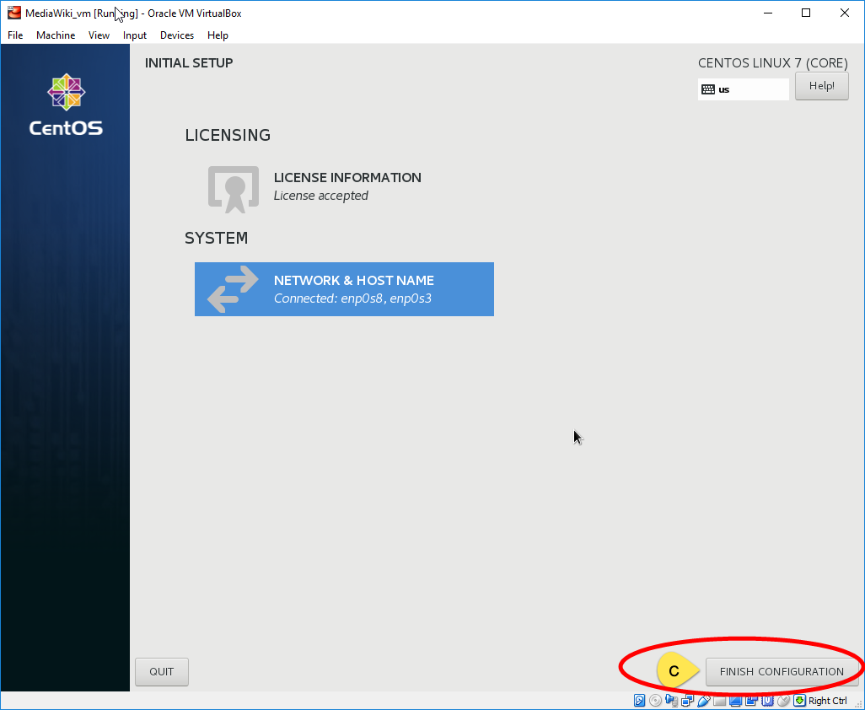

**Note:**  This might take about 15 minutes. While this is taking place the virtual machine may turn black and you might see a series of process running.

1. Sign in.

Once it is done rebooting, the virtual machine will start. You will be greeted with a user interface to log in. By default, the created user, Laura -in this case, will be displayed.

1. Click on “Not Listed”.

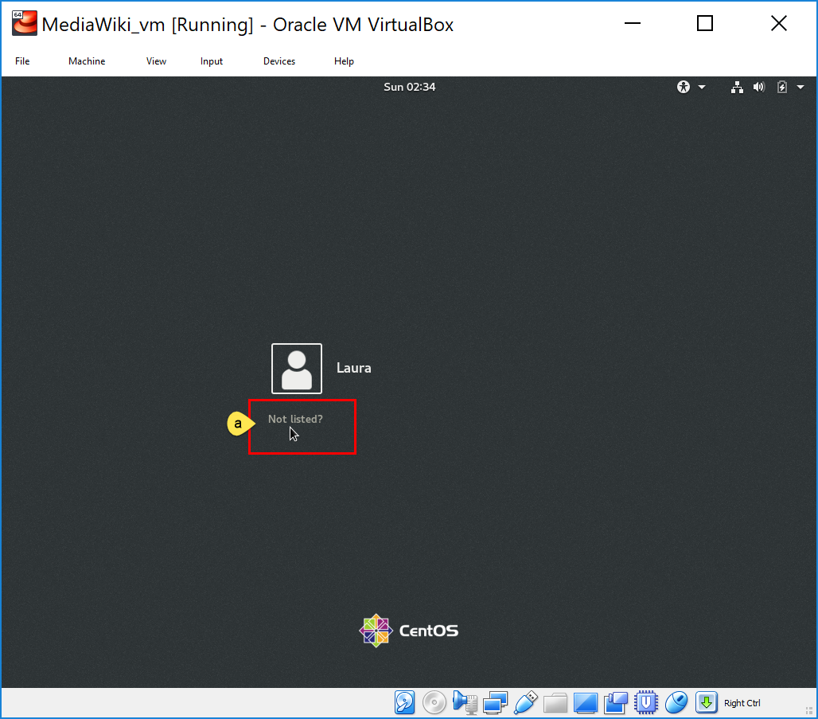

1. Type in “root”
2. Press “Next”

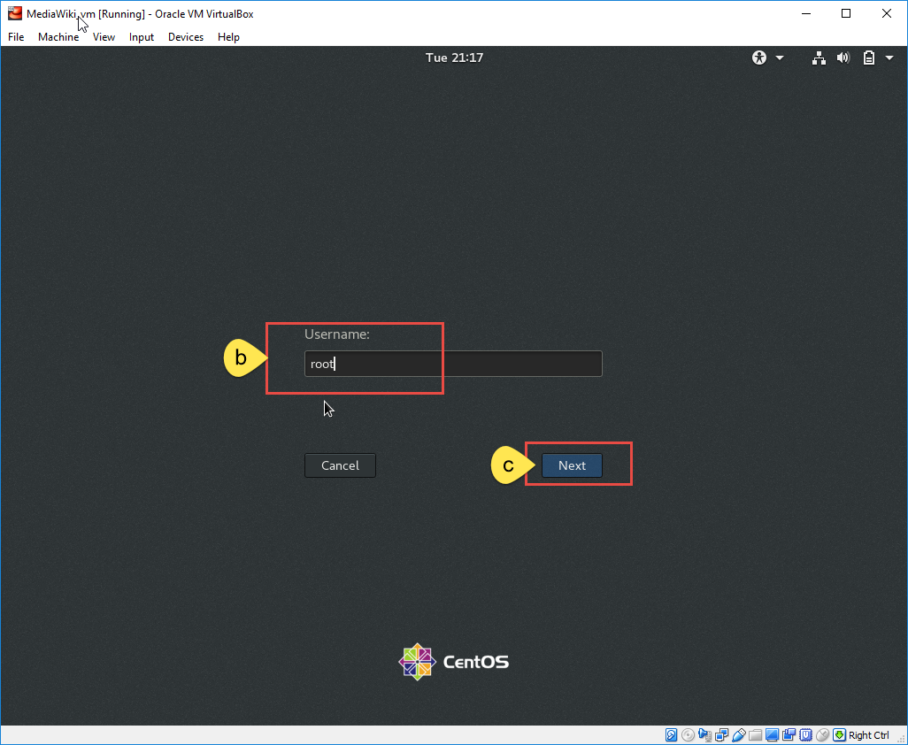

1. Type in the password you defined for the root user at creation (‘root’ user and the password you assigned a couple of steps ago),
2. Click on “Sign in” or press ‘Enter’

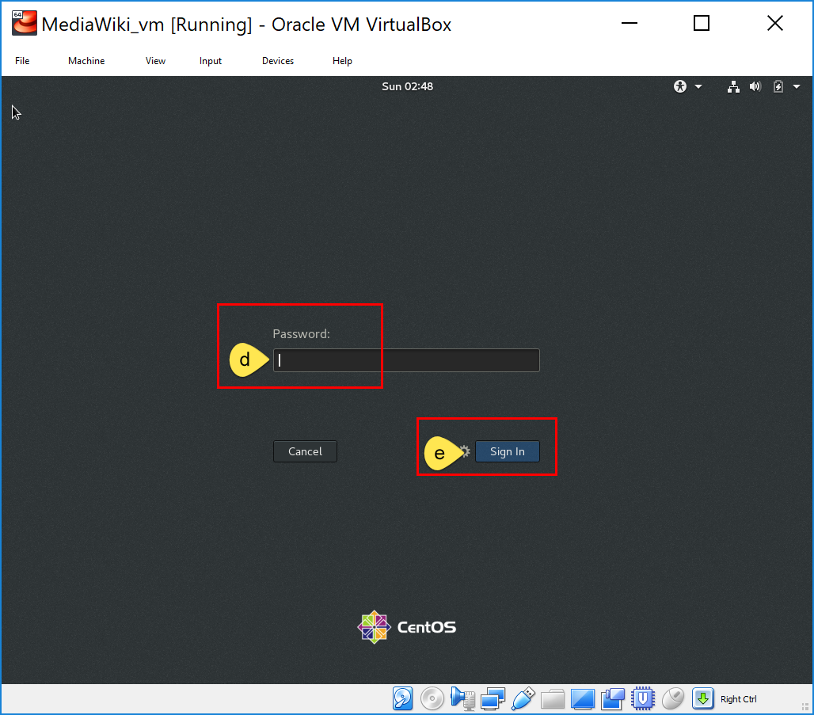

1. Welcome screen. Confirm that the correct language is selected and click on “Next”.

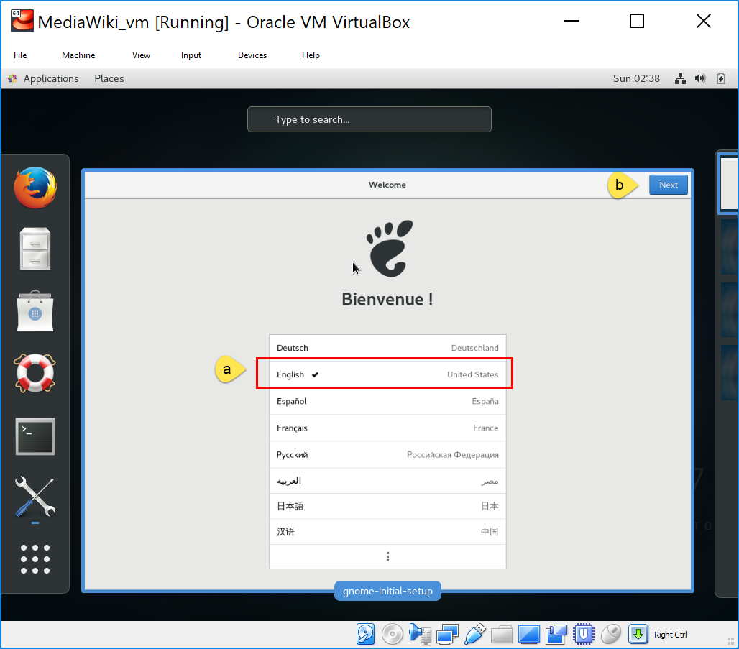

1. Confirm that the Keyboard layout is the one of your preference and click on “Next”.

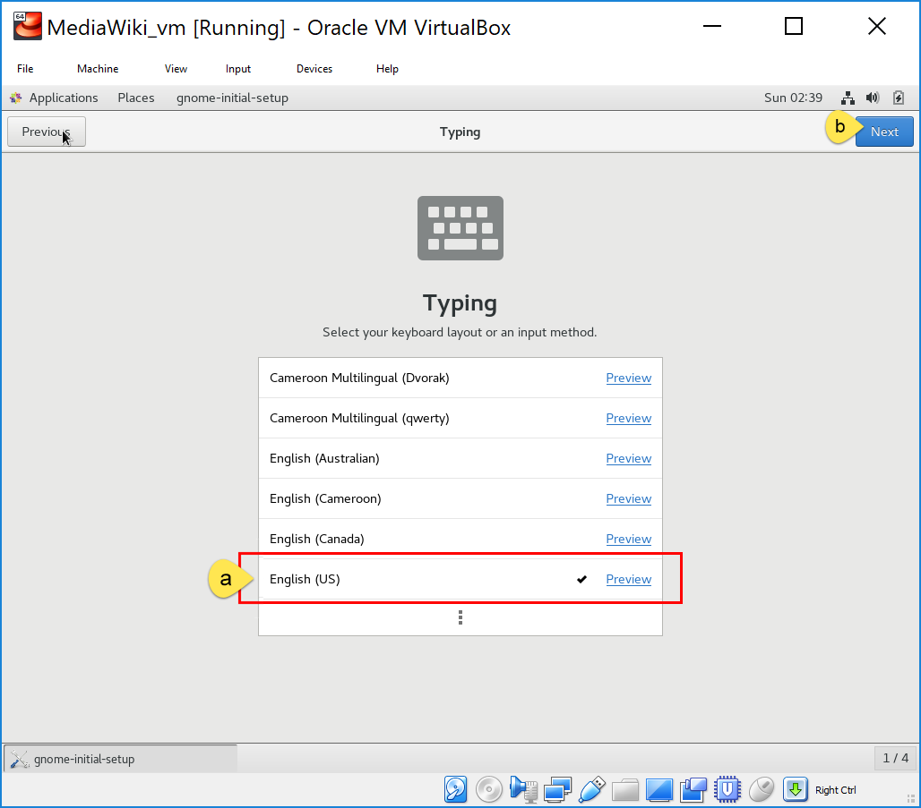

1. Privacy:
   1. Confirm that the “Location Services” is “ON”.
   2. Click on “Next”.

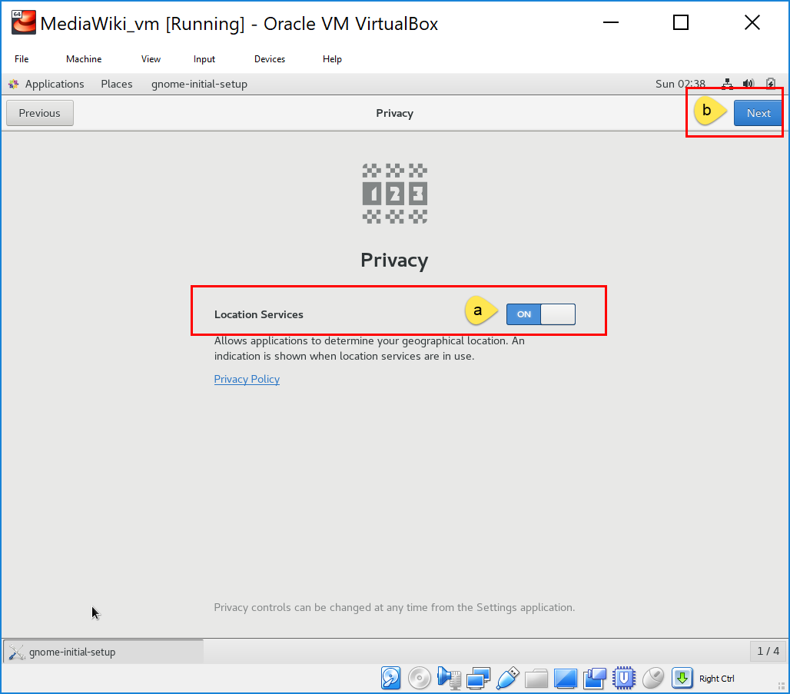

1. You may skip the Connect Your Online Accounts page.

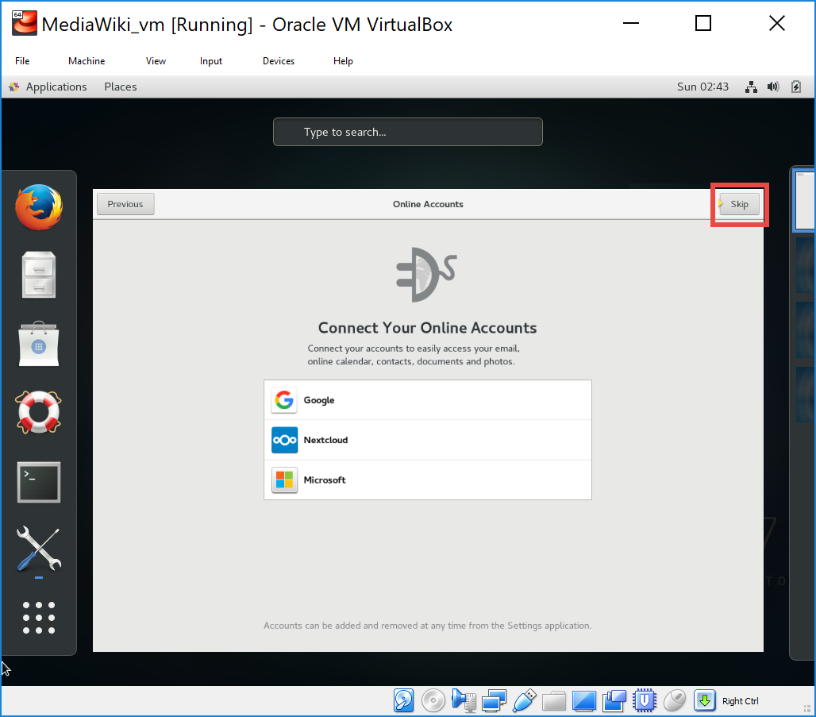

1. Click on “Start using CentOS Linux”

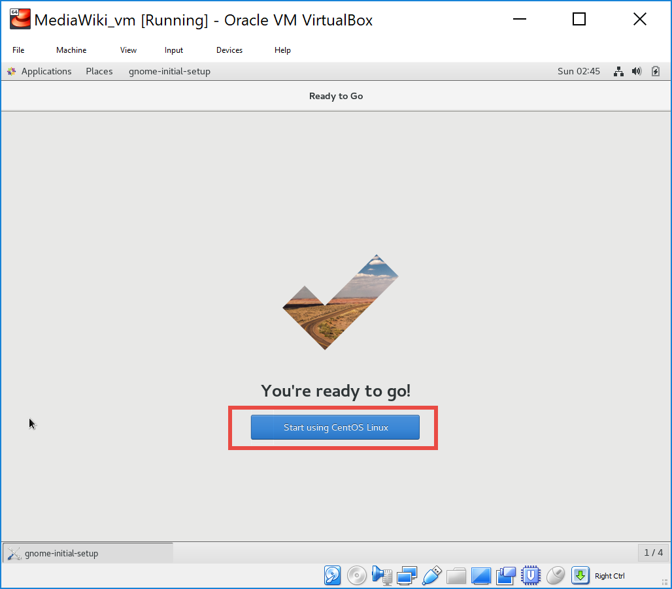

1. Getting Started. You may watch getting started videos. Close the window when you are done and ready to start.

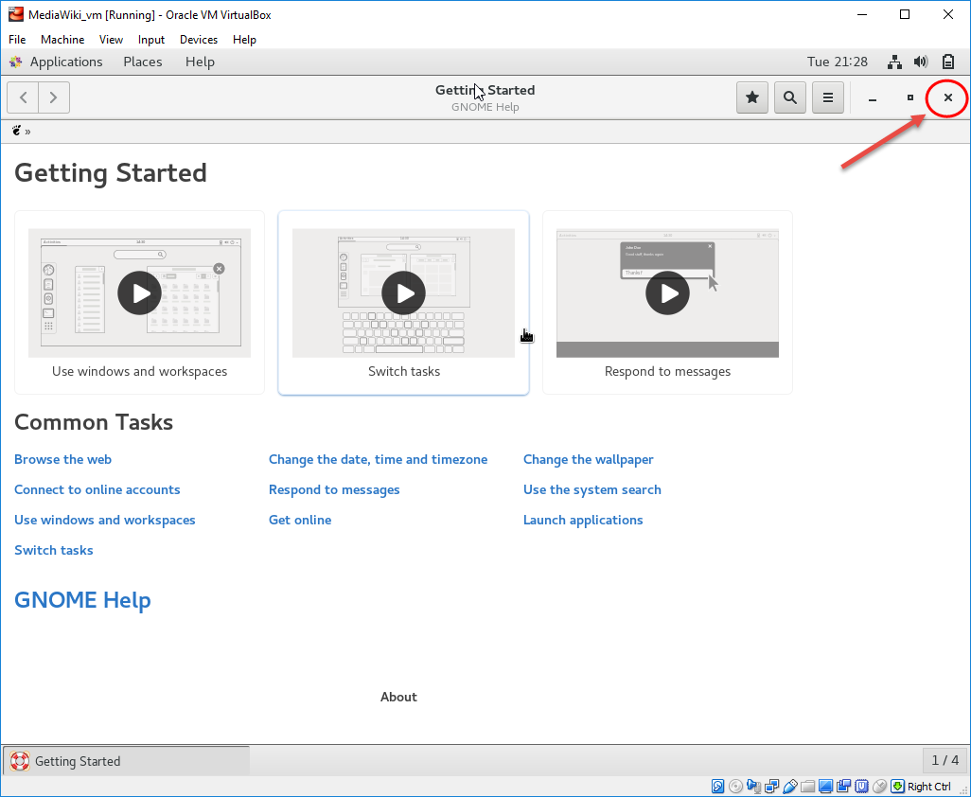

1. Select the “Network” icon on the upper right corner.
   1. Click on the arrow of the “Ethernet connection”
   2. Click on the arrow.
   3. Click on “Wired Settings”

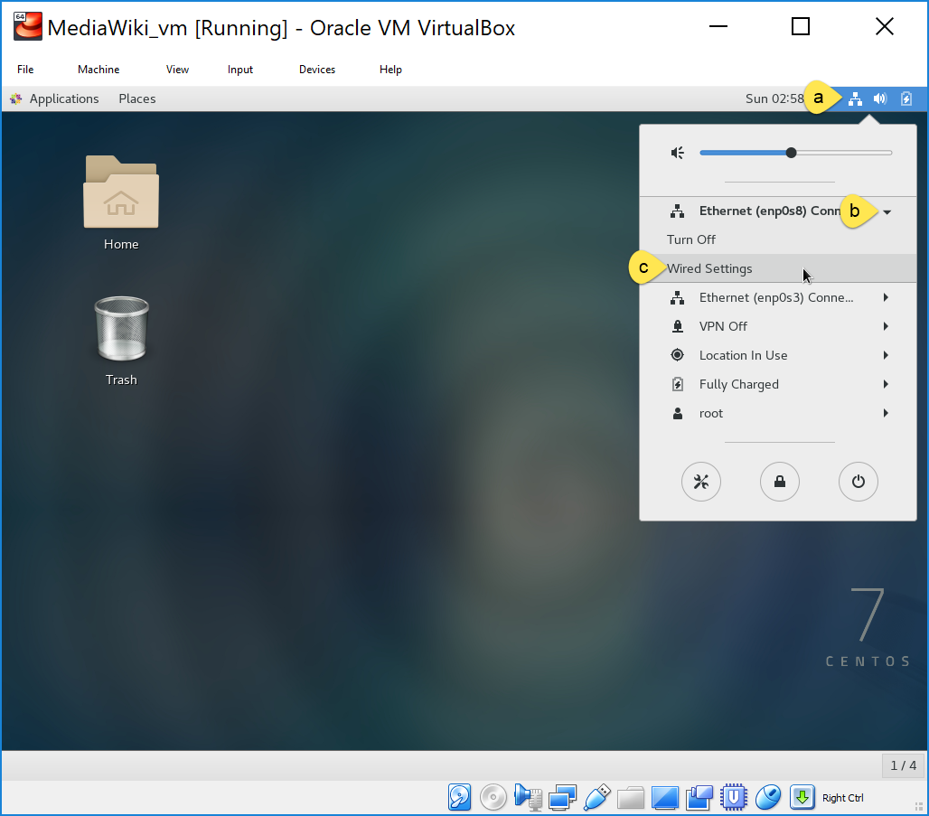

1. Click on the “Settings” gear of each Ethernet connection that you may have and confirm they are set to “Connect automatically”. Write down the given IP address if you have not done already.

Once you are done, close the ‘Settings’ page.

* 1. Click on the gear icon of the first Ethernet
     1. Check to “Connect Automatically”
     2. Click on “Apply”
  2. Click on the gear icon of the second Ethernet
     1. Check to “Connect Automatically”
     2. Click on “Apply”
  3. Click on the “X” to close the “Network” window.

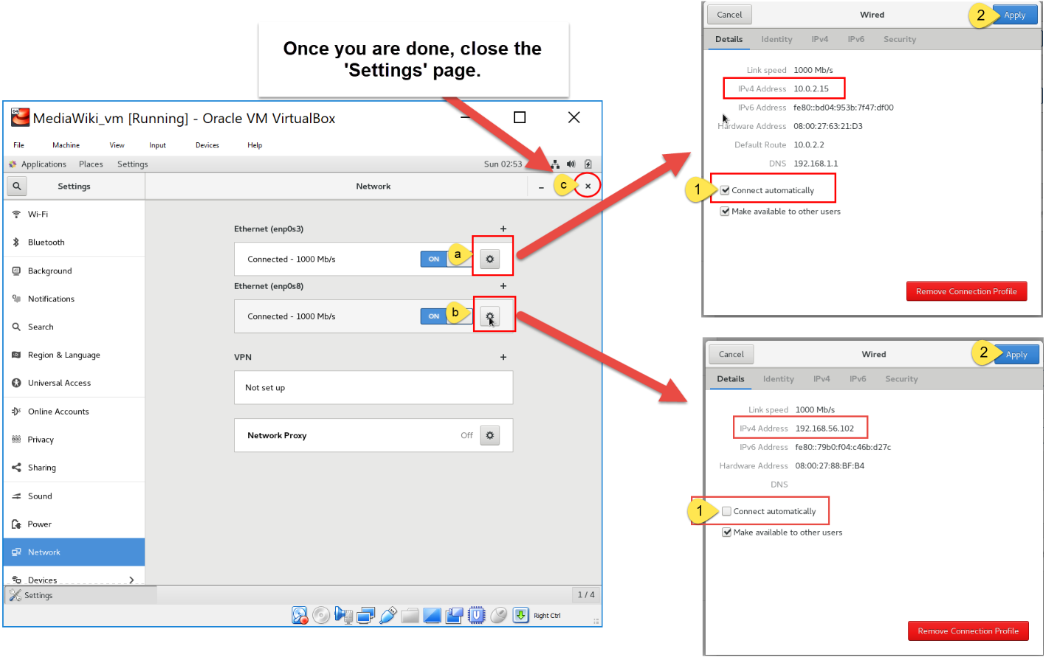

***Note:***

If at any point the machine goes to sleep mode, you will see a dark screen. Click on it to wake it up. You will see a blue screen with date and time: tap on the “Enter” key or use the scrolling button (center) in the mouse to display the log in page. Type in the root password and click on “Unlock”.

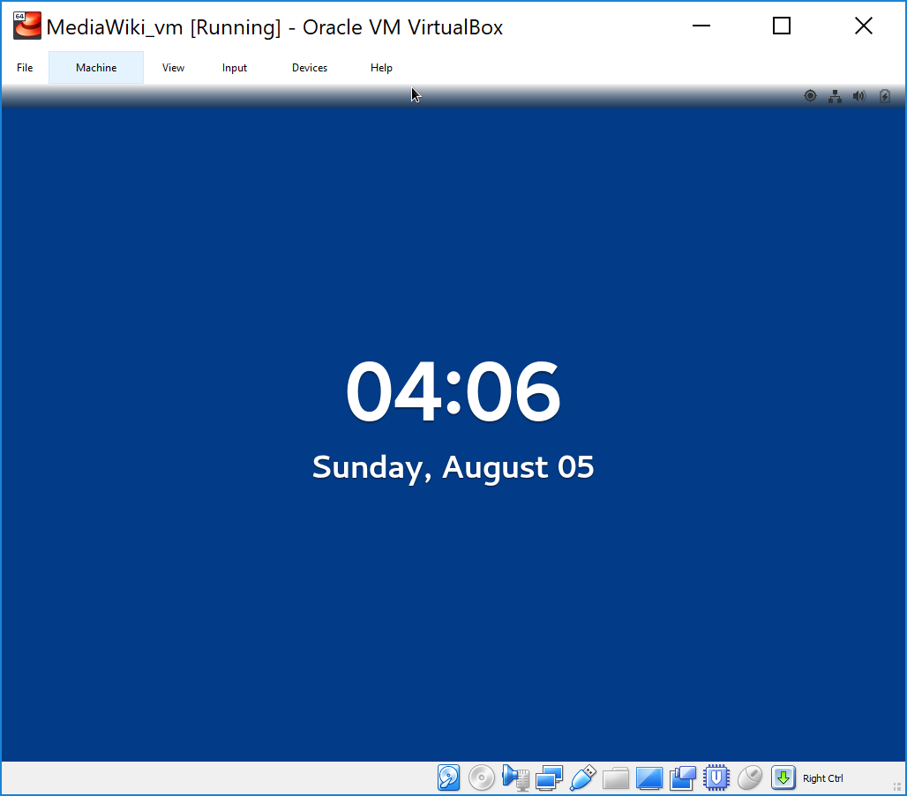 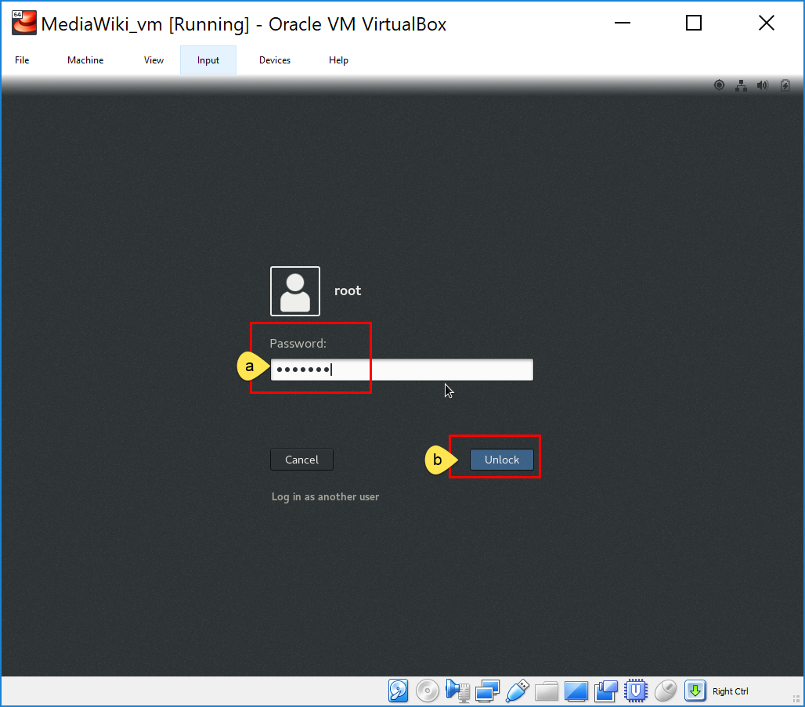

# Preparing for Software Installation

1. Access the Terminal
   1. Click on “Applications”
   2. Click on “Terminal”

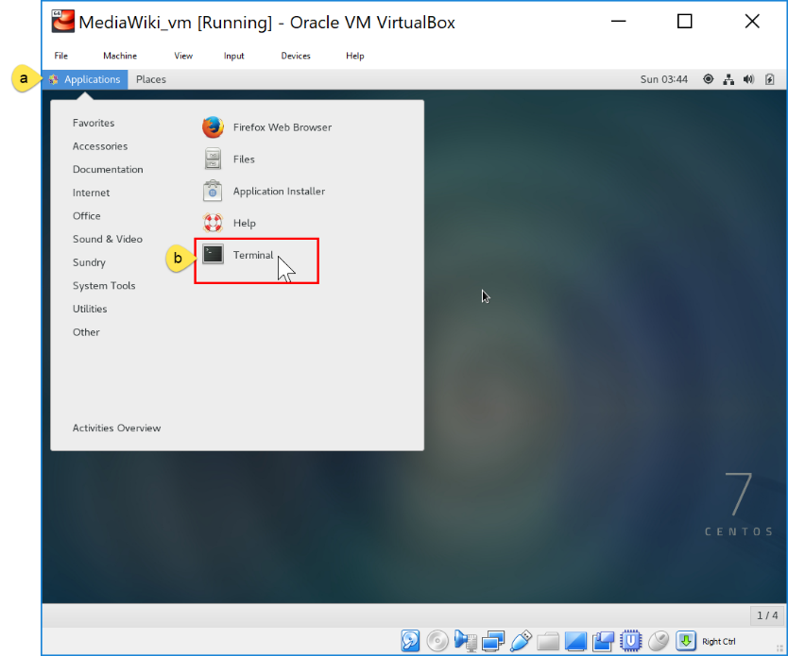

1. Check connectivity

ping google.com

Watch as the packets are transmitted.

Use “CTRL + C” to stop.

Look for a confirmation “0% packet loss”. If this is not the case, go back and check your network connectivity.

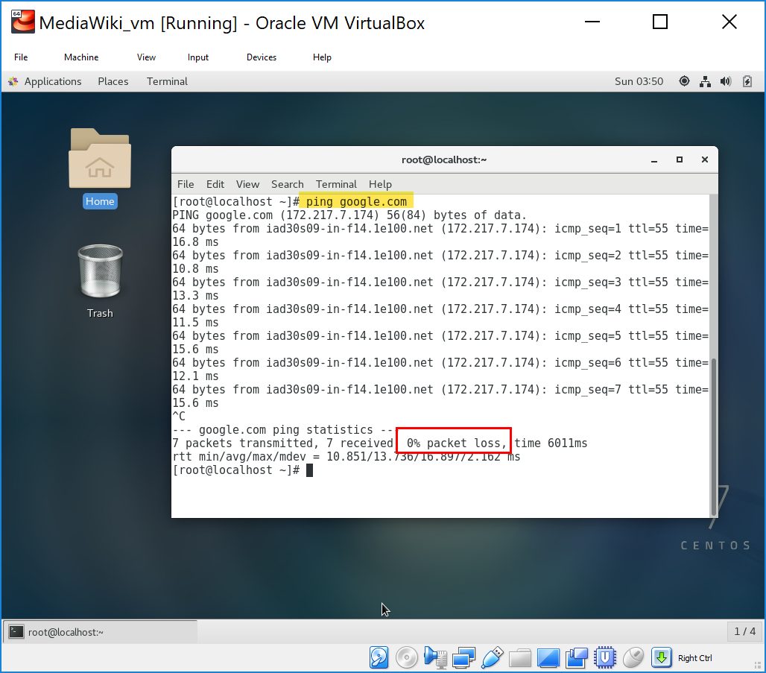

Type in “clear” to clear the terminal.

clear

1. Make sure that EPEL (Extra Packages for Enterprise Linux) is installed. This is to help download and install other software from the internet.

yum epel release

If it is already install you will see a confirmation message saying so, if not it will start checking and downloading for “base”, “extra”, and “updates” packages.

In my case it has been already installed.

If you get a message saying “No such command: epel”, then you need to install it.

yum –y install epel-release

Look for a “Complete!” confirmation message at the end.

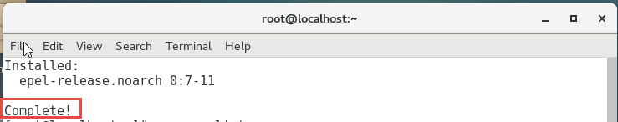

To confirm that you have it installed, run the following command:

yum repolist

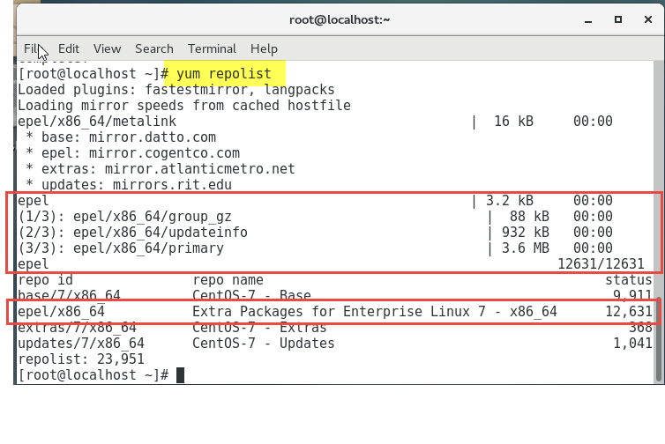

1. Check for any necessary package updates.

yum update

It will be scanning all the packages that are available on the system. We will see a list of all the pending updates. Type “y” to confirm to update packages. Type in again “y” to accept installation.

Look for a “Complete!” confirmation message at the end.

**Note:** that this might take several minutes.

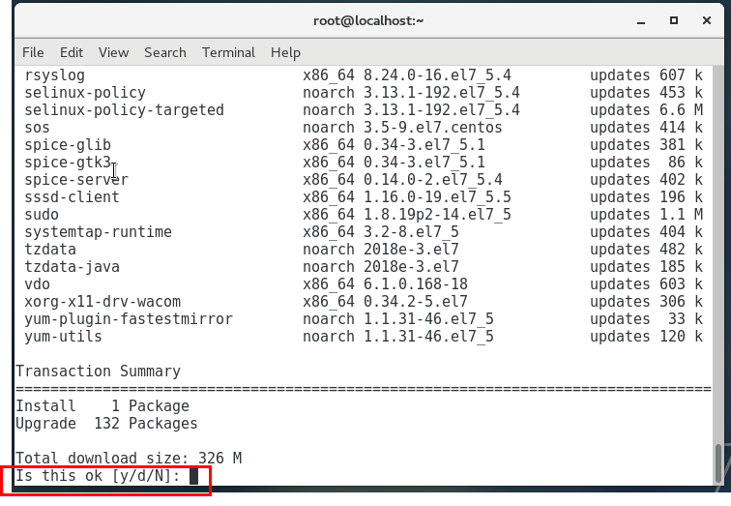 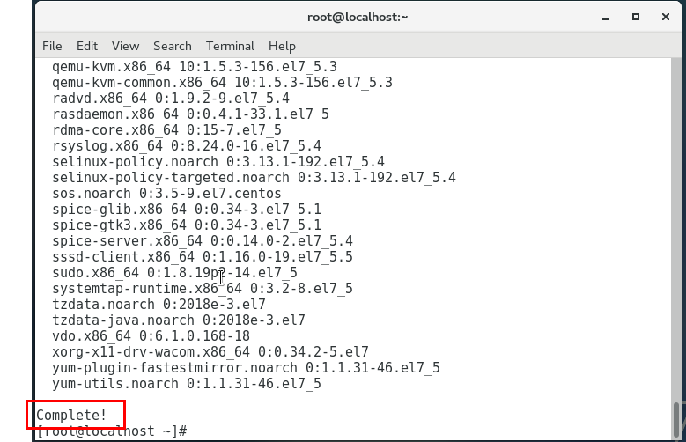

# Install Apache web server

yum install httpd

* 1. To confirm installation type in: y
  2. Confirm once more, type in: y
  3. Look for a “Complete!” confirmation message at the end.

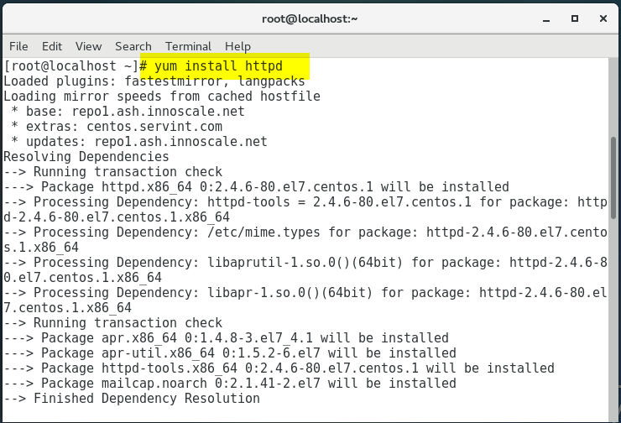 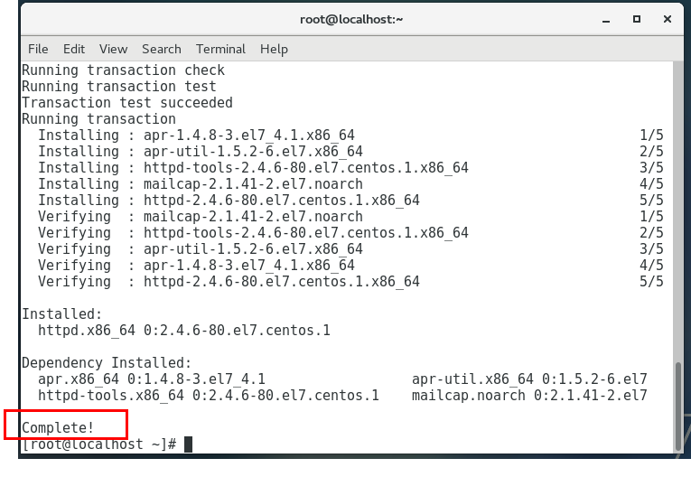

* 1. Allow Apache through the firewall

firewall-cmd --permanent --add-port=80/tcp

firewall-cmd --permanent --add-port=443/tcp

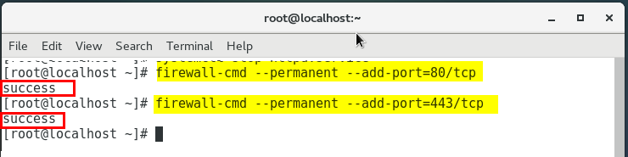

Reload the firewall

firewall-cmd --reload

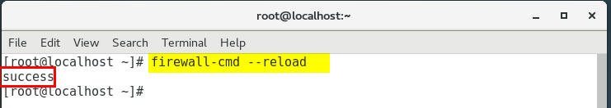

* 1. Add HTTP and HTTPS to the public zone and reload the firewall

firewall-cmd –permanent --zone=public --add-service=http

firewall-cmd –permanent --zone=public --add-service=https

firewall-cmd --reload

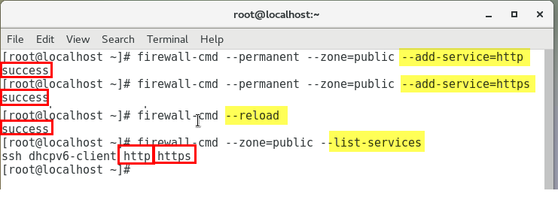

* 1. Start apache

systemctl start httpd.service

* 1. Check that it is running

systemctl status httpd.service

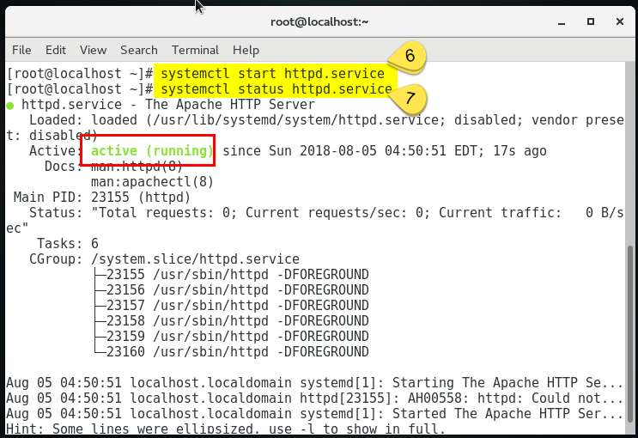

* 1. Configure Apache to start on Boot

systemctl enable httpd.service

It creates a symlink:

From: /etc/system/system/multi-user.target.wants/httpd.service

To: /usr/lib/system/system/httpd.service

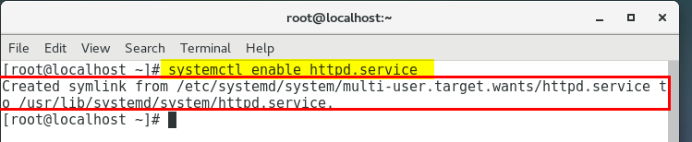

* 1. Do a spot check. On your host computer go to a browser and type in your server IP address in the URL

http://192.168.56.102

You should see the Apache testing page.

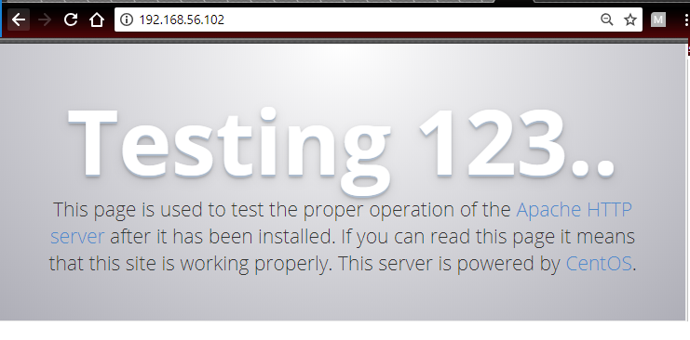

# Installing MariaDB

1. Install MariaDB

yum install mariadb-server

Type in “**Y**” to confirm installation when prompted.

Look for a “Complete!” confirmation message at the end.

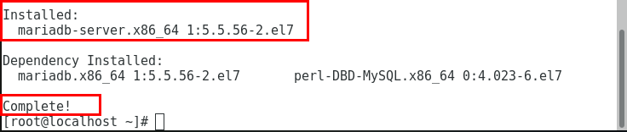

1. Enable MariaDB to start on Boot

systemctl enable mariadb.service

This creates a symlink:

From: /etc/system/system/multi-user.wants/mariadb.service

To: /usr/lib/system/mariadb.service

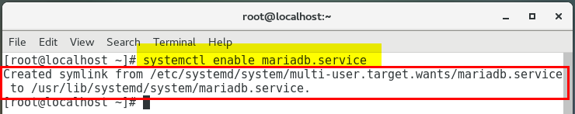

1. Start MariaDB

systemctl start mariadb.service

1. Check its status

systemctl status mariadb.service

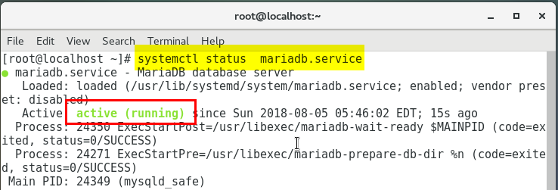

1. Address security concerns:

Assign root password, remove anonymous user accounts, disable root logins outside the localhost, remove test databases, and reload privilege tables. Below are our recommendations.

mysql_secure_installation

After running the command, you will first press ‘Enter’, since you have not set the root password yet.

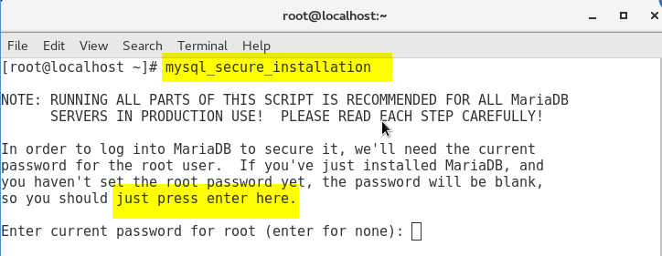

* 1. Assign a password to root user: Y

Give a password and re-enter password

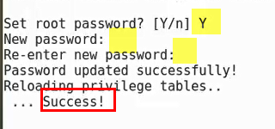

* 1. Remove anonymous user account: Y

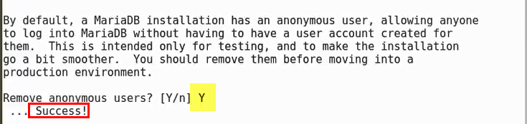

* 1. Disable root login outside the localhost: Y

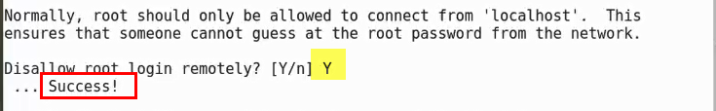

* 1. Remove test database: n

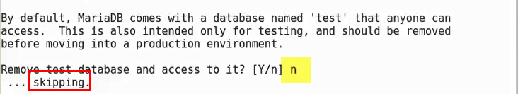

* 1. Reload privilege tables

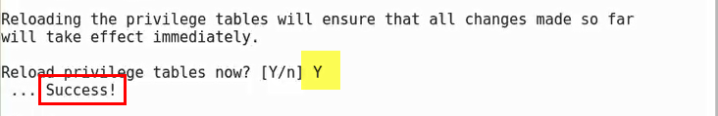

Once the installation is complete, you will see:

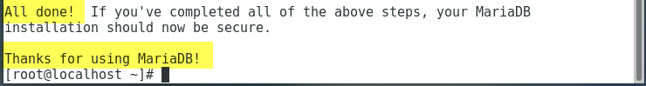

# Installing PHP

1. IUS repo is required for php 5.6

wget https://centos7.iuscommunity.org/ius-release.rpm && sudo rpm -Uvh ius-release.rpm

1. Install the PHP 5.6 interpreter and PHP MySQL and other extensions

yum install nginx php56u php56u-devel php56u-fpm php56u-gd php56u-mbstring php56u-mcrypt php56u-mysql php56u-pdo php56u-opcache php56u-pear php56u-xml php56u-xmlrpc php56u-memcached

When prompted, type ‘y’ to confirm installation.

Look for a “Complete!” confirmation message at the end.

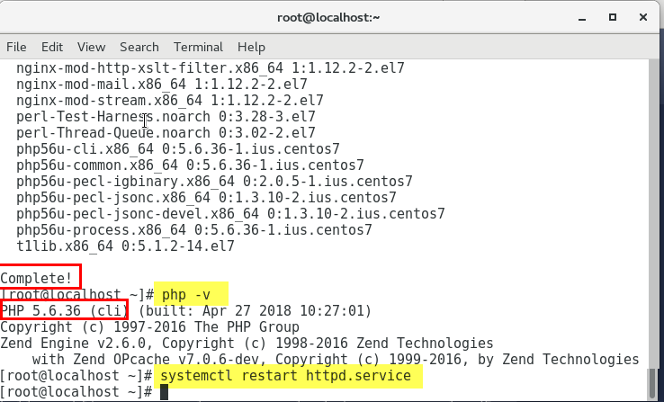

1. Confirm php version

php -v

1. Re-start the Apache server to make it will now load PHP module.

systemctl restart httpd.service

1. Check that PHP and Apache are talking to each other by creating a file inside /var/www/html/ directory.
   1. Navigate to the directory and create a php test file

gedit /var/www/html/info.php

* 1. Type in

<?php phpinfo(); ?>

* 1. Click on ‘Save’

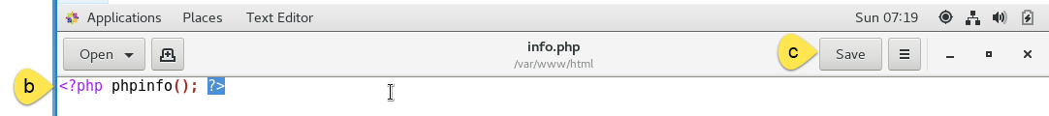

* 1. Grant permission

chmod 755 /var/www/html/info.php

* 1. Go to your host computer, open a browser and type in http://<your network IP address>/info.php”.

http://192.168.56.102/info.php

You should see the php information page:

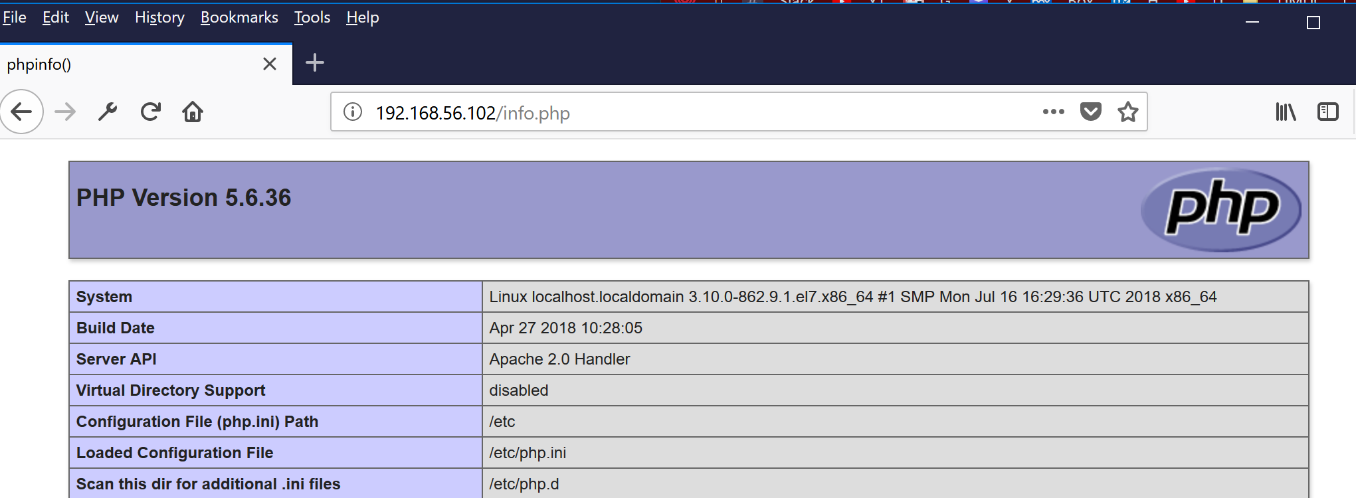

# Install MediaWiki

1. Log into the Linux computer. For the purpose of these instructions we have created a virtual machine with CentOS 7 operating system. So, if you are following the previous instructions, and if you have not done so already, start the virtual machine and log in as root user. See instructions above on how to do so.
2. Open your terminal.
3. Check that Apache is installed and running.

systemctl status httpd.service

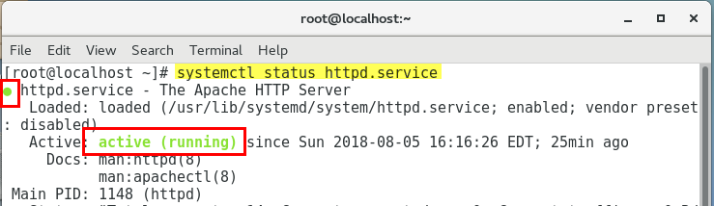

1. Check that MariaDB is installed and running.

systemctl status mariadb.service

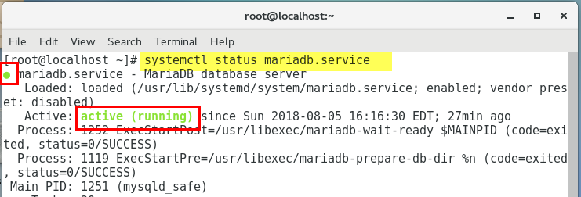

1. Check that php is installed

php -v

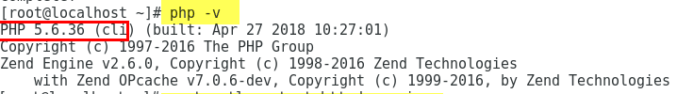

1. Log into mysql using root user and the given password

mysql -u root -p

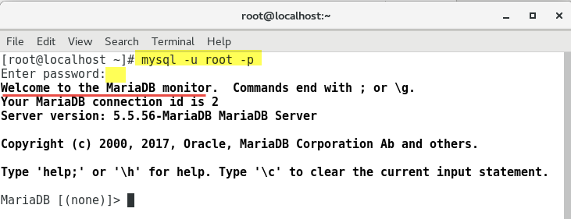

1. Create a database for the media wiki

create database my_wiki;

Being my_wiki the given database name

Look for a “OK” confirmation message

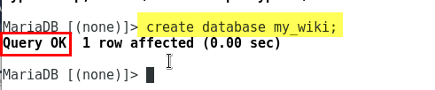

1. Create a database user and grant permission giving all privileges to my_wiki database

GRANT ALL PRIVILEGES ON my_wiki.* to ‘laura’@’localhost’ IDENTIFIED BY ‘kd(9Usz5’ WITH GRANT OPTION;

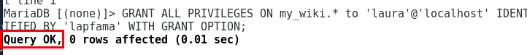

1. Install “wget” – it might have been already installed; if so, you will see a message saying that it is already installed.

yum install wget



1. Download MediaWiki

wget https://releases.wikimedia.org/mediawiki/1.27/mediawiki-1.27.4.tar.gz

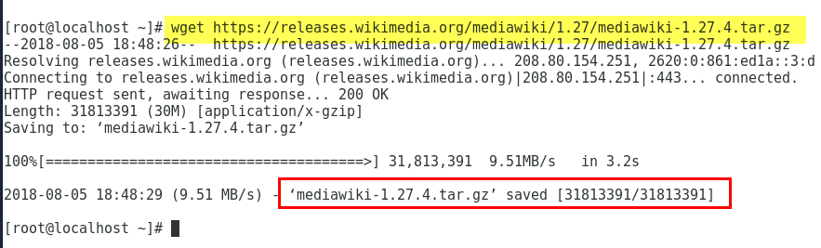

1. Since it is a ‘tar’ file we need to extract it.

tar -xvf mediawiki-1.27.4.tar.gz

* 1. To confirm that it has been extracted; type in: ls

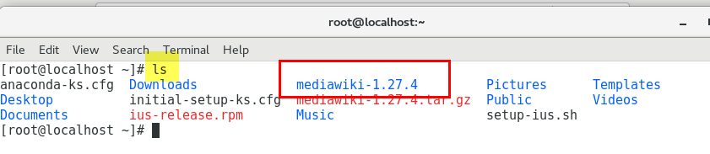

1. Copy directory to the directory inside /var/www/html/media >> we are creating the ‘media’ folder

cp -r mediawiki-1.27.4 /var/www/html/MediaWiki

Navigate to the destination folder and list content to confirm success.

cd /var/www/html/MediaWiki/

ls

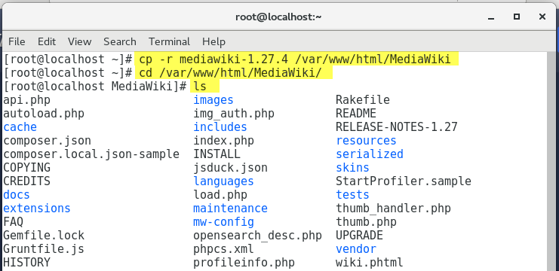

1. Change ownership and permissions for the ‘media’ directory.

First, navigate back to the home directory, then change ownership; finally, change permissions.

cd ~

chown -R apache:apache /var/www/html/MediaWiki/

chmod 755 /var/www/html/MediaWiki/

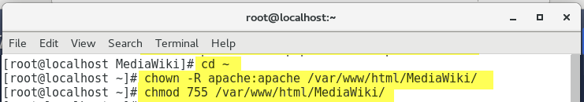

1. Check that everything went well.

Open the browser and navigate to <http://[your-ip-address]/MediaWiki>

<http://192.168.56.102/MediaWiki>

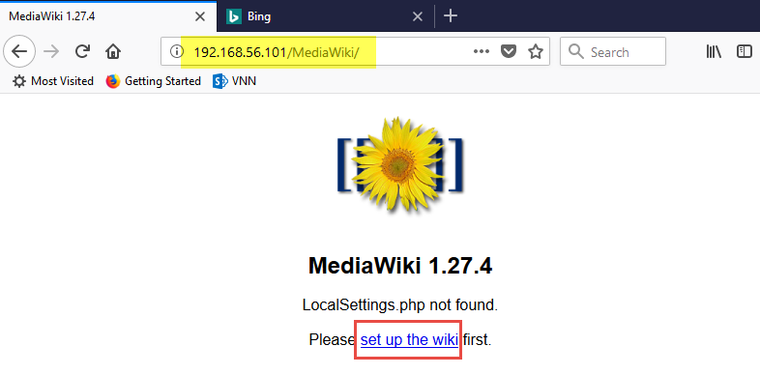

Since we will be download a file once the configuration is over, for simplicity it is easier if you access the MediaWiki url using the virtual machine’s browser:

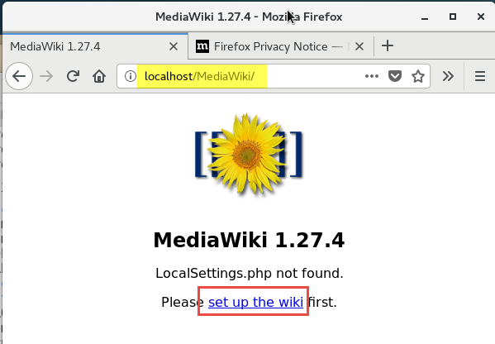

Click on the “set up the wiki” link.

This will take you to the <http://localhost:8080/mw-config/index.php> page. If you are doing this in the host computer use the IP address instead of ‘localhost:8080’. Though it is recommended to do it in the virtualbox

***Note:*** If you see a warning sign that the connection is not private, click on ‘Advance’ and then on ‘Proceed to 192.168.56.56 (unsafe)’

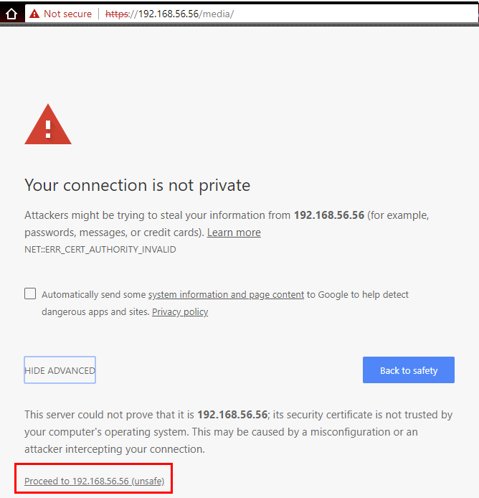

1. Click on “Continue 🡪” or change your language if desired.

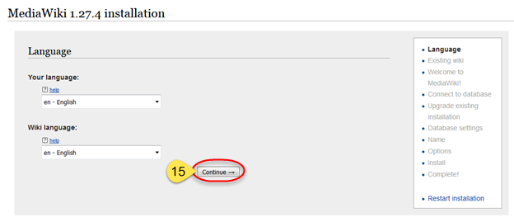

1. Scroll down to the bottom of the page and click on “Continue 🡪.”

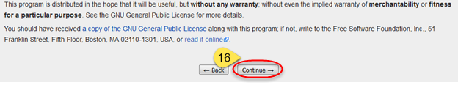

1. Leave “Database type:” as “MySQL (or compatible)” as the “or compatible” references MariaDB. Leave all other information as is,
2. Type in a “Database password:” and
3. Click on “Continue 🡪.” You can use the same password as your MariaDB install if desired.

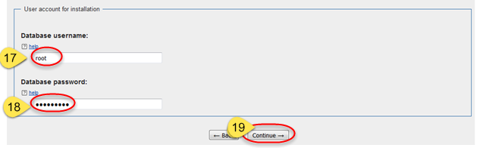

1. Leave “Storage engine:” as InnoDB and
2. change “Database character set:” to UTF-8 as these settings mimic what is installed with the Meza install.
3. Click on “Continue 🡪.”

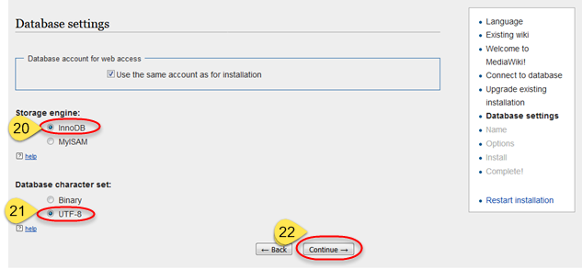

1. Give your Wiki a name such as “My Wiki,”

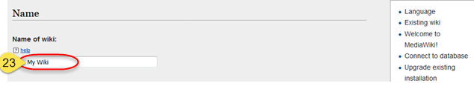

1. Type in a username and
2. Type in a password. You can use the same password as your MariaDB install if desired.
3. Confirm password.
4. Leave all other settings as is (including “Email address:”
5. Click on “Continue 🡪” at the bottom of the page.

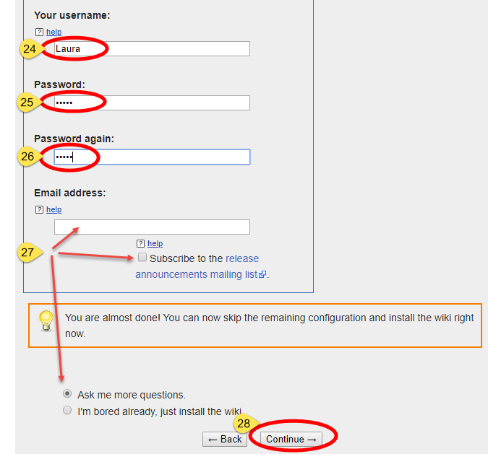

1. Leave all settings as is and scroll down to the bottom of the page and click on “Continue 🡪.” Some extensions may be enabled from here for future use, but for now at the time of this writing, no extensions are needed.

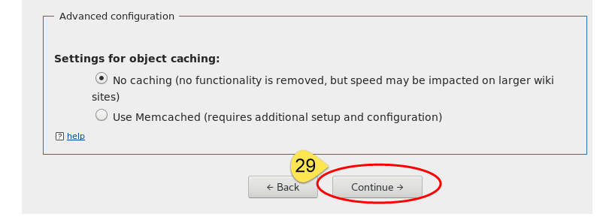

1. Click on “Continue 🡪.”

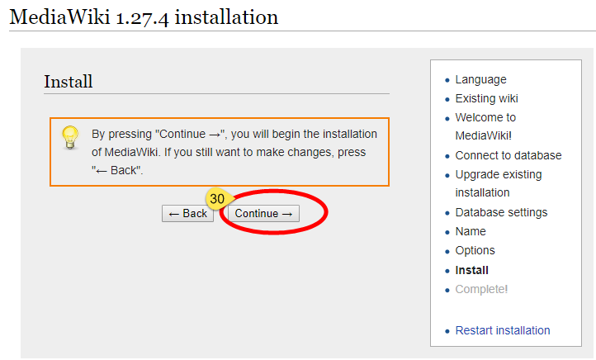

1. Click on “Continue 🡪.”

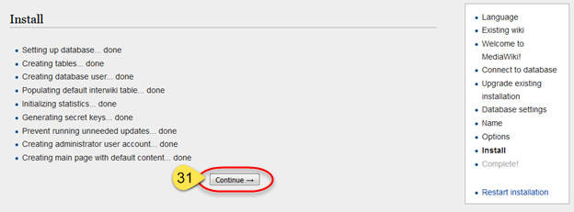

1. A dialogue will appear with an option to open or save a LocalSettings.php file. **Save this file in the MediaWiki folder** at the root level or save it somewhere else first and move it to the MediaWiki folder thereafter.
2. A confirmation message will be displayed confirming the success of the installation.

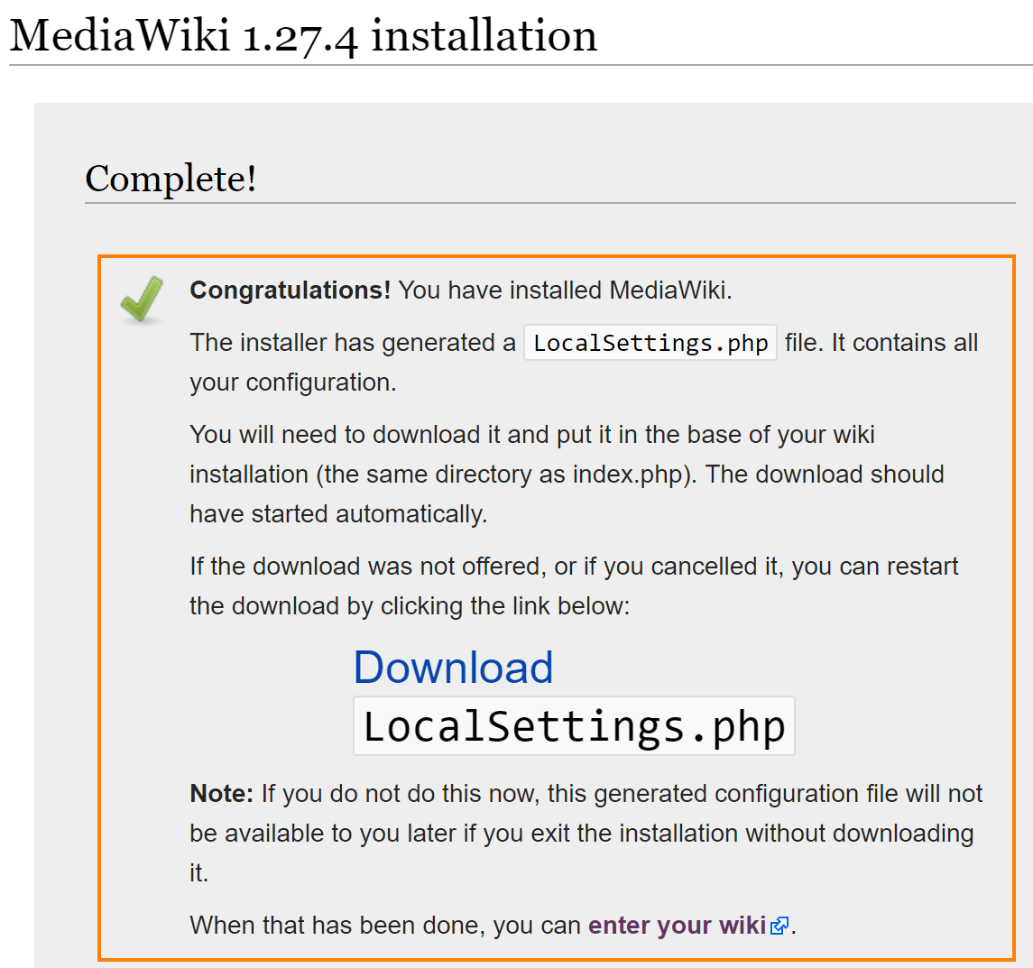

*Note: If you missed to download the “LocalSettings.php” file on the previous step, you may click on the link “Download” and save it. This will be your last chance of doing so.*

1. Access in your browser: <http://localhost:8080> and login using the username and password you created during installation to confirm that the MediaWiki installation was successful.
2. If successful, log out; if not, review the steps described above and try again.

# NASA EVA Gamification Extension Installation Instructions

These steps may need to be altered, if the GitHub repository is different than what the Summer 2018 semester used.

The following instructions are all commands to be run from the terminal.

1. . Make sure the “LocalSettings.php” file that you save on the precious section is placed at the root level of the “MediaWiki” folder.

cp -r Downloads/LocalSettings.php /var/www/html/MediaWiki/

1. Download and extract the files and folders from [GitHub] (<https://github.com/SWEN670NASAEVA2/NASA_EVA_Gamification>)

Unzip NASA_EVA_Gamification-master.zip

1. Copy the entire `NASA_EVA_Gamification-master` directory to the `MediaWiki/extensions/NASA_WIKI_Gamification` directory. Pay attention that when we create the new directory inside the Mediwiki/extensions, we are dropping the “-master” part of the name.

cp -r Downloads/NASA_EVA_Gamification-master /var/www/html/MediaWiki/extensions/NASA_EVA_Gamification

1. Navigate to the “MediaWiki” directory and open the `LocalSettings.php` file so you can edit it:

gedit /var/www/html/MediaWiki/LocalSettings.php

a) Change the default “MediaWiki” logo:

Find **$wgLogo**. and replace everthing after the '=' sign with the following:

"$wgResourceBasePath/extensions/NASA_EVA_Gamification/images/nasa-wiki-logo.png";

The line should look like:

$wgLogo = "$wgResourceBasePath/extensions/NASA_EVA_Gamification/images/nasa-wiki-logo.png";

1. Add global variables

Scroll down to the bottom of the page (after the last line) and paste the following lines:

# Nasa Eva Gamification >> Phase 1

wfLoadExtension('NASA_EVA_Gamification');

$wgShowDebug = true;

$wgDebugComments = true;

$wgEnableParserCache = false;

$wgCachePages = false;

# Nasa Eva Gamification >> Phase 2

$wgPhase2Images = "$wgResourceBasePath/extensions/NASA_EVA_Gamification/images/";

$wgProfilePage=$wgServer.$wgResourceBasePath."/index.php/Special:UserGamificationProfile";

$wgBadges=array('platinum'=>'500','gold'=>'200','silver'=>'100','bronze'=>'50');

$wgPoints = array(0=>50, 1=>100);

$wgLeaderBoardPointScale=100;

1. Save the file.

***Note****: $wgShowDebug = true; is for debugging purposes; so, it is recommended to have it set to “true” in a development environment and set to “true” in a production environment.*

5. Update changes

a) Navigate to the MediaWiki directory and run the following command:

cd /var/www/html/MediaWiki/

php maintenance/update.php

6. Move and replace the following files “From” the specified directory “To” the specified directory.

Navigate to the “extensions/NASA_EVA_Gamification” directory

cd extensions/NASA_EVA_Gamification

a) Move file: WikiPage.php

From directory: ` MediaWiki /extensions/NASA_EVA_Gamification/`

To directory: ` MediaWiki /includes/page/`

mv -f WikiPage.php /var/www/html/MediaWiki/includes/page/

b) Move file: Revision.php

From directory: ` MediaWiki /extensions/NASA_EVA_Gamification/`

To directory: ` MediaWiki /includes/`

mv -f Revision.php /var/www/html/MediaWiki/includes/

7. Open a web browser and access your local instance: <http://localhost:80/MediaWiki/> or from the host computer: http://<IP Address>/MediaWiki/ In our case: http://192.168.56.102/MediaWiki/

1. Click “Log in” on the upper right corner link.
2. Use the username and password that you created when installing the Wikimedia or create a new user.
3. From the left hand-side navigation select `Special pages`
4. Scroll down (almost until the end of the page) and verify that under the `Other Special pages` section the "User Gamification Profile" extension has been successfully installed.
5. Click on `User Gamification Profile` to confirm that the extension was install successfully.

Please note that since you have not added or edited any page, you will see just your username and name (if you have it defined) with a message stating:  
*No data found!*

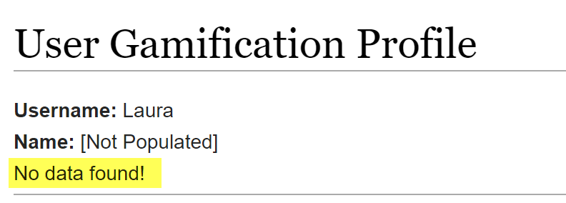

8. You are Done!!

## Note

This extension was designed for MediaWiki 1.27 or later.

# Additional Tips

1. After installing CentOS, consider the documentation at <https://wiki.centos.org/HowTos/Network/SecuringSSH> to secure shell access to the VM.
2. With shell access configured correctly, the system can be connected to via the ssh port, instead of the console. As such, the VM can be started in Headless Mode, via the down arrow next to the green Start button in the VirtualBox Manager screen.
   1. Select your virtual machine
   2. Click on the arrow next to the ‘Start’ button
   3. Select ‘Headless Start’

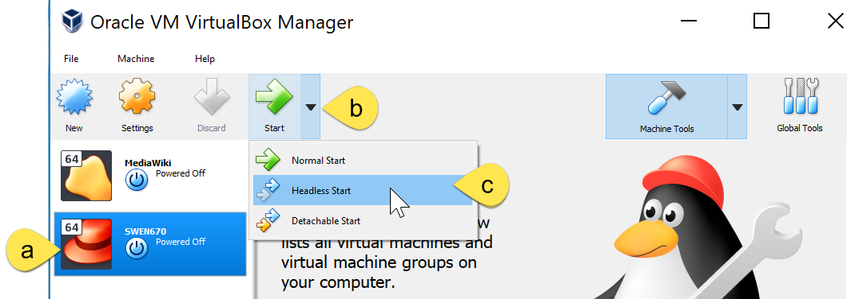

This will start the VM, but without a console, to free up the host’s screen. Once the VM is started in Headless Mode, the VirtualBox Manager window can be closed without effecting any VMs running.

1. gedit comes pre-installed with the ISO-DVD installation. It is a great tool to edit using a user interface editor.
2. If it’s forgotten, displaying the contents of /var/www/html/MediaWiki/LocalSettings.php; it will show the database username and password, which can be used for direct mysql access..

# Earning Points

## By Creating a Page

1. Click on “Talk” on the upper right navigation.
2. Click on “Create”

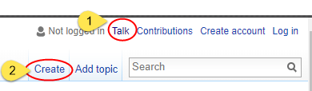

1. Type in your text, scroll down, and click on “Save page”.

## By Editing a Page

1. Click on “Main page” on the left-hand side navigation or navigate to the page you want to edit.
2. Click on “Edit”

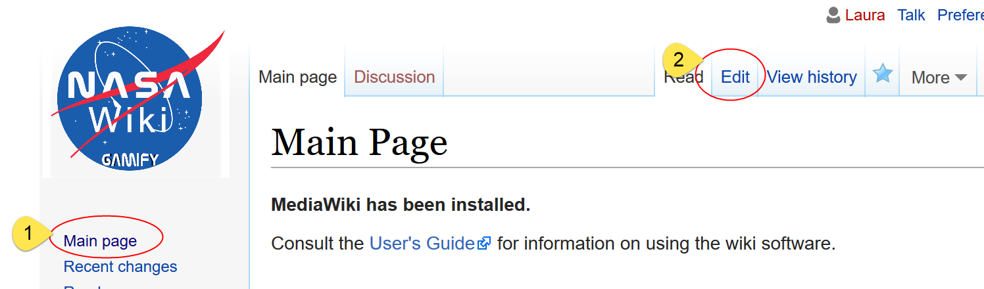

1. Edit/Add the content of the page, scroll down, and click on “Save page”.

# Checking Your Points and Badges Earned

Visit the “User Gamification Profile” to see points being added and badges being earned as you add and edit posts.

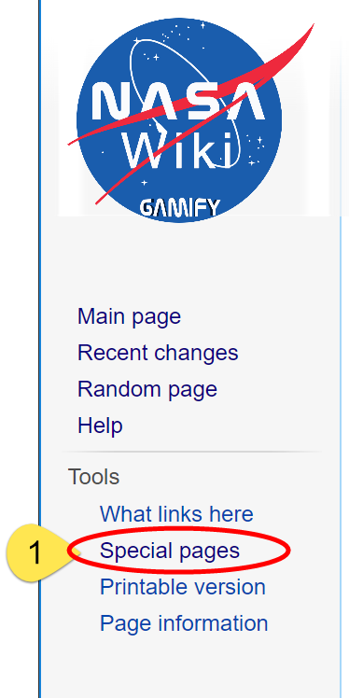

1. Click on “Special pages”
2. Scroll down
3. Under “Other special pages” click on “User Gamification Profile”
4. See the dashboard being displayed.

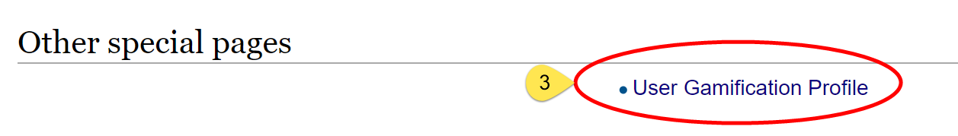

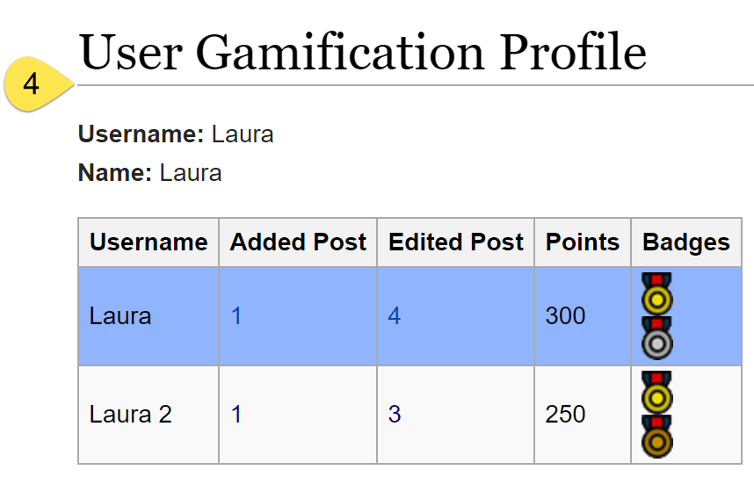

# Appendix A - Enabling Virtualization

Please note that you will have to re-start your system, so save and close any open windows/applications.

* + 1. Re-start your system.
    2. Depending on the brand you have, the hot key you will have to use to enter the BIOS on re-start. For example, for Lenovo computers, you will see a message that reads something like this,

*To interrupt normal startup, press Enter or tap here.*

* + 1. Once you interrupted the normal startup, select the F key that will enter the BIOS Setup Utility.

For example, for Lenovo computers is:

***F1*** *to enter the BIOS Setup Utility*

* + 1. Moving with your ‘right’ and ‘left’ arrows select the “Security” tab.
    2. Moving with your ‘up’ and ‘down’ arrows select ‘Virtualization.
    3. Press ‘Enter’ to select
    4. Moving with your ‘up’ and ‘down’ arrows select ‘Enabled’
    5. Press F10 to save changes and exit.
    6. Select ‘Yes’ to confirm.

Click here to continue with the CentOS installation instructions.